

**FACULTY OF SCIENCE & TECHNOLOGY**

BSc (Hons) Software Engineering

May 2021

Habitat: A Web Application to Monitor Linux Configurations and Reduce High Impact Failures

by

Andrew Parkhill

Faculty of Science & Technology

Department of Computing and Informatics

Final Year Project

**Abstract**

This dissertation presents the development process for Habitat, a web application which monitors the configuration of Linux devices and the configuration of application’s hosted on Linux devices, allowing development teams to increase visibility of their environment configurations. The goal with this application was to assist development teams in ensuring consistency across environments and help to avoid costly failures associated with misconfiguration.

The tooling associated with the development process has been outlined, with a development environment including a Raspberry Pi acting as a physical Linux device as well as three Linux Virtual Machines provisioned for testing purposes.

The final solution was developed using a combination of the Kanban and Prototyping methodologies with the goal of delivering a proof of concept. A thorough evaluation phase was also undertaken which outlines any challenges encountered. The source code has been written with professionalism and scalability in mind, ensuring the ability to facilitate the addition of further features.

Research has been focussed around the area of environment configuration and the adverse impact failures can have on organisations. The literature review undertaken helped inform the final requirements for the application by providing wider knowledge around the area of configuration failures. While the idea has been derived from personal experiences in industry, the final solution has not been developed with a specific client in mind.

|  |
| --- |
| **Dissertation Declaration**  I agree that, should the University wish to retain it for reference purposes, a copy of my dissertation may be held by Bournemouth University normally for a period of 3 academic years. I understand that once the retention period has expired my dissertation will be destroyed.    **Confidentiality**    I confirm that this dissertation does not contain information of a commercial or confidential nature or include personal information other than that which would normally be in the public domain unless the relevant permissions have been obtained. In particular any information which identifies a particular individual's religious or political beliefs, information relating to their health, ethnicity, criminal history or sex life has been anonymised unless permission has been granted for its publication from the person to whom it relates.    **Copyright**    The copyright for this dissertation remains with me.    **Requests for Information**    I agree that this dissertation may be made available as the result of a request for information under the Freedom of Information Act.  **Signed**: Andrew Parkhill .    Name: Andrew Parkhill    Date: 13 May 2021    Programme: BSc (Hons) Software Engineering |

**Original Work Declaration**

This dissertation and the project that it is based on are my own work, except where stated, in accordance with University regulations.

**Signed**: Andrew Parkhill .

Name: Andrew Parkhill

Date: 13 May 2021

TABLE OF CONTENTS

1 INTRODUCTION 1

1.1 Problem Definition 1

1.2 Rationale 1

1.3 The Solution 2

1.4 Aims and Objectives 2

1.5 Project Overview 2

2 LITERATURE REVIEW: ORGANISATIONAL IMPACT OF SOFTWARE FAILURE 4

2.1 Failures 4

2.1.1 Common Causes of Failure 4

2.1.2 Configuration Failures 4

2.1.3 Prevention vs Detection 5

2.2 Organisational Impact of Configuration Failures 5

2.2.1 Reputational Impact 5

2.2.2 Financial Impact of Failure 6

2.3 DevOps and Configuration Management 6

2.3.1 The Role of DevOps 6

2.3.2 Communication Challenges 6

2.3.3 Security in DevOps Tools 7

2.4 Development Team Considerations 8

2.4.1 Environmental Consistency 8

2.4.2 Accountability 8

2.5 Literature Review Conclusion 8

3 METHODOLOGY 9

3.1 Methodology Selection 9

3.1.1 Selecting a Methodology 9

3.1.2 Methodologies Considered 9

3.1.3 Chosen Methodology: Hybrid approach- Prototyping/Kanban 10

3.2 Planning 11

3.2.1 Gantt Chart 11

3.2.2 Estimation 11

3.2.3 Prioritisation 11

3.2.4 Evaluation of the Solution 11

4 ANALYSIS 13

4.1 Requirements 13

4.1.1 Requirements Elicitation 13

4.1.2 Minimum Viable Product 13

5 DESIGN 15

5.1 Modelling 15

5.1.1 Use Case Modelling 15

5.1.2 Database Design 16

5.2 User Interface Design 16

5.2.1 Bootstrap 16

5.3 Design Decisions 16

5.3.1 Linux 16

5.3.2 Programming Language Selection 17

5.3.3 Frameworks 18

5.3.4 Framework Selection 18

5.3.5 Third Party Libraries 19

5.3.6 Scalability 20

5.4 Security 20

5.4.1 Secure Shell Protocol 20

5.4.2 Flask and Security 20

6 IMPLEMENTATION 22

6.1 Development Process 22

6.1.1 Database 22

6.1.2 User Interface Development 22

6.2 Development Tools 23

6.2.1 Git 23

6.2.2 Integrated Development Environment (IDE): Pycharm 24

6.3 Architecture 24

6.3.1 Jump Server 24

7 EVALUATION 25

7.1 Testing 25

7.1.1 Quality 25

7.1.2 Requirements 25

7.1.3 Defects 25

7.2 Evaluation of Aims and Objectives 25

7.2.1 Research organisational impact of configuration failures 25

7.2.2 Identify an appropriate methodology to complete all requirements efficiently 26

7.2.3 Analyse problem domain and identify requirements for a Minimum Viable Product which provides a minimum level of functionality to prove the concept 26

7.2.4 Research the most appropriate technology stack to create the web-based solution 26

7.2.5 Design the solution from technical perspective with appropriate modelling 26

7.2.6 Implement the solution to meet the specified requirements with a focus on achieving the MVP 26

7.2.7 Deliver of Aims and Objectives 27

8 CONCLUSION 28

8.1 Project Summary 28

8.2 Future Work 28

8.3 Evaluation of Issues 28

REFERENCES 29

APPENDIX A: PROJECT PROPOSAL 32

APPENDIX B: ETHICS CHECKLIST 36

APPENDIX C: FIRST PROGRESS REVIEW 38

APPENDIX D: INITIAL GANTT CHART 39

APPENDIX E: REVISED GANTT CHART 40

APPENDIX F: REQUIREMENTS SPECIFICATION 41

APPENDIX G: ESTIMATIONS 43

APPENDIX H: WIREFRAMES 47

APPENDIX I: TEST CASES 50

APPENDIX J: DEFECT LOGS 55

APPENDIX H: ARTEFACT CONTENTS 56

LIST OF FIGURES

Figure 1: Objectives 2

Figure 2: Percentage of breaches caused by malicious attack (IBM Security 2020) 7

Figure 3: Selection Criteria for Methodology 9

Figure 4: Prototyping Model (Guru99, 2021) 10

Figure 5: Kanban Board 10

Figure 6: Features on Kanban board map directly to branches in Git 13

Figure 7: Use Case Model 15

Figure 8: Database Design 16

Figure 9: Red Hat/ Linux Market Share (Red Hat, 2019) 17

Figure 10: Popularity of Programming Languages (PYPL 2021) 17

Figure 11: Features of Java and Python (Khoirom et al. 2020) 18

Figure 12: Django and Flask Comparison 19

Figure 13: Python Developers Survey 2020 (Jetbrains 2020) 19

Figure 14: Secure Shell Connection (SSH Academy 2021) 20

Figure 15: Right- Database structure in SQLite, Left: Database model for environment 22

Figure 16: Outlining use of dynamic values and conditional statement provided by Jinja2 23

Figure 17: Code sample outlining inheritance used to provide consistent look and feel 23

Figure 18: Functionality provided by Pycharm 24

Figure 19: Jump server architecture diagram 24

# INTRODUCTION

Software failures can originate from a multitude of areas, from badly defined requirements to poor project management practices. Failures can also originate from uncontrolled technical risks, such as hardware or software misconfiguration. Small scale development teams may be in a position to keep abreast of such technical challenges through face-to-face interaction however when the development process scales up to a global level and is dispersed across time zones, coordination and synchronization becomes more complex and time consuming (Mohd Fauzi et al. 2010). The specific challenge of interest in this dissertation is the validation of server configurations, and the impact that any potential misconfiguration can have on organisations.

## Problem Definition

While development teams may possess more in-depth knowledge of the specifics of an application and its dependencies, they are often reliant on infrastructure teams to manage environment configurations. This can cause issues if new configuration updates are miscommunicated. Tools are particularly important for distributed teams to conserve and distribute knowledge gathered by team members in different locations (Dorairaj et al. 2012).

The risks associated with incorrectly configured environments are high, particularly within a production environment and the challenge of keeping track of configurations is constantly evolving, with any issues proving expensive both financially and in terms of reputation. It is important that the focus of development teams is therefore on prevention rather than detection of issues. Identifying and preventing issues before they reach the end user will always prove more favourable.

While working for a large globally distributed development team, the task of monitoring environment configurations was undertaken through a series of scripts which produced an email output outlining the current state of configuration. Across a large-scale development team, these scripts proved difficult to manage and communication was very challenging in maintaining the scripts effectively. This creates a risk for an organisation as a minor miscommunication could prove costly if scripts are not maintained effectively.

## Rationale

Minimising the risk of software failure is important for all organisations. Development teams may feel content that they have a thoroughly tested application, however a simple configuration issue on a production server could have potentially catastrophic consequences. Take the example of a financial trading platform; The latest version of the source code is dependent on Python version 3.8. If the production environment is misconfigured with an older Python version, the application will fail. If this issue is not intercepted, there is the potential for severe ramifications both in terms of cost and reputation. The New York Stock Exchange experienced such an issue in 2015, when the exchange experienced a four-hour outage and “the root cause was determined to be a configuration issue” (CNN 2015). A four-hour outage for such a high-profile trading platform has global consequences and this highlights the organisational impact of overlooking configuration issues prior to deployment.

Currently large organisations use a series of Configuration Management tools coupled with custom scripting to manage IT infrastructure. These scripts are brittle and therefore prone to interference because of the lack of modularity when changes are made to the infrastructure (Vanbrabant and Joosen 2013). The creation of a web-based tool to monitor environment configurations will allow development teams to take a more proactive approach and resolve issues before they escalate and become public.

## The Solution

The software artefact itself takes the form of an application built as a proof-of-concept which allows development teams to monitor environment configurations. The application acts as a bespoke solution which will either replace or supplement existing scripting solutions. The application takes into consideration the key security implications and the source code aims to minimise complexity to ensuring maintainability with limited manual intervention from development teams.

## Aims and Objectives

The overall aim of the project was to provide an application for use within development teams, providing a visual prompt for any unexpected configuration changes within their environments. Figure 1 lists the key objectives associated with the project and the success criteria associated with each:

|  |  |  |
| --- | --- | --- |
| **Number** | **Objective** | **Success Criteria** |
| 1 | Research organisational impact of configuration failures | In depth literature review documented around the topic of the organisational impact of software and hardware failures |
| 2 | Identify an appropriate methodology to complete all requirements efficiently | Methodology researched and selected. Documentation outlining selection process |
| 3 | Analyse problem domain and identify requirements for a minimum viable product (MVP) which provides a level of functionality to prove the concept | MVP requirements identified and documented which provide a level of functionality which can demonstrate system capabilities and act as proof of concept |
| 4 | Research the most appropriate technology stack to create the web-based solution | Documentation providing reasoning behind technology decisions |
| 5 | Design the solution from a technical perspective with appropriate modelling | Models and design diagrams produced which consider the problem domain and provide a clear design in preparation for implementation |
| 6 | Implement the solution to meet the specified requirements with a focus on achieving the MVP | Requirements have been fulfilled and application meets at least the requirements of the MVP |
| 7 | Evaluate final solution and project as whole | Project plan reviewed and learning points documented |

Figure 1: Objectives

## Project Overview

The literature review (chapter 2) outlines the research conducted into the area of environment configuration which helps to inform the design of the final solution. This is followed by the selection of an appropriate methodology to effectively coordinate the project (chapter 3). Chapter 4 then moves into the analysis phase of the project, where requirements are gathered, and a minimum viable product is defined. The design process (chapter 5) is directly informed by the requirements and outlines the design decisions taken prior to implementation. The implementation phase (chapter 6) then provides detail on the tooling and architecture of the development environment. The final evaluation of the project (chapter 7) then outlines an overall evaluation and the artefact and identifies any issues and learning points, with a conclusion in chapter 8, providing a summary and detailing potential future work.

# LITERATURE REVIEW: ORGANISATIONAL IMPACT OF SOFTWARE FAILURE

Organisations are judged on the quality of their software provision, and high-profile failures can have a detrimental impact on customer confidence, and in turn the financial stability of an organisation. This chapter will discuss the organisational impact of such failures. Central to the delivery of quality software is a high level of knowledge and control around the IT infrastructure. The core aspects of building and sustaining a sound IT infrastructure are based on a solid foundation and the ability to enforce policies and procedures to strengthen that foundation (Papows, J. 2010).

## Failures

Software development projects are complex and challenging to manage and the detection of faults is one of the major challenges. All software contains faults, and undoubtedly some of these faults will result in failures (Hamill and Goseva-Popstojanova 2009). It is therefore important that the risk of failure is mitigated. Due to the level of complexity involved in software projects, it is possible that even the most obvious risks could be overlooked, and organisations must have robust processes and tools in place for risk mitigation.

### Common Causes of Failure

Software failure can originate from multiple sources. Faults can be introduced at any phase of the software life cycle, that is, they can be tied to any software artifact (e.g., requirements, design, and source code) (Hamill and Goseva-Popstojanova 2009). Some of the most common failures originate from faults in the requirements specification, coding faults, data related issues and misconfiguration. Thorough testing practices should be in place to identify faults in source code, however issues around configuration can easily go unnoticed if not communicated effectively.

### Configuration Failures

As software configurations continue to grow in complexity, misconfiguration has become one of major causes of software failure (Wang et al. 2018). There is also an increasing focus on development teams being globally dispersed to provide 24/7 resourcing. Dispersing teams globally offers the advantage of 24-hour productivity. However, it also presents organisations with a challenge in maintaining effective communication. The main issue comes from the challenge of communication control and coordination, which relate to the geographical area, temporal, and different cultural background (Podari et al. 2020). There is therefore an increased reliance for development teams on effective tooling which can provide consistent visibility of issues across time zones. The artefact aims to assist with improving the visibility of such issues.

Issues of misconfiguration, if left undetected can have a financial or reputational impact as well as increasing the possibility of exposing security vulnerabilities. A 2018 IBM report identified that human error was responsible for two-thirds of compromised records including a historic 424% jump in misconfigured cloud infrastructure (IBM, 2018). Reliance on manual processes which require a level of human intervention increases the possibility of exposing organisations to misconfigurations and potential security vulnerabilities. It is therefore key that organisations look to adopt effective automation practices and alleviate human intervention where possible. Today’s software industry demands a process that will help develop software which can continuously adapt and adjust to the changes in the customer requirements (Gonen and Sawant 2020).

### Prevention vs Detection

In all facets of engineering, prevention of issues is preferred to the detection of issues. Fault Prevention is a proactive strategy to identify all potential areas where a fault can occur and to close those gaps (Shivakumar, S. 2015). If an issue has been detected, the problem has effectively already occurred and the organisation has been exposed to risk whereas if the focus is on prevention, organisations are afforded a level of protection against issues occurring and risks can be mitigated. This artefact was designed with this in mind, with a view to providing detection capabilities, which act to protect against issues occurring.

While prevention may be preferred to detection, it is very challenging to forecast issues in software projects. Within the software development lifecycle, it is important that testing is conducted across various environments so that issues can be identified within a safe haven before being deployed into a production environment. This allows teams to find the root cause of issues before deploying to a customer facing environment. While working across multiple environments, detection and tracing of issues becomes key and monitoring tools play an important role in allowing organisations to detect and track issues before they are exposed to the outside world.

Central to the detection of issues for software engineers is the use of application log’s which act as a log of the execution of the program and allow engineers to identify issues. Logs are one of the most important sources of information for debugging and maintaining software systems. The valuable information in logs motivates the development of log analysis tools (Hassani et al. 2018). The importance of log’s must therefore inform the design of the artefact, in ensuring that developers have a means for monitoring log files.

Effective tooling is key in ensuring that issues become visible. Teams will only be prompted to take effective action when an issue becomes visible. Issues which remain out of site will remain out of the control of the development team. This therefore indicates that the artefact must provide clear visibility across the team so that issues can be intercepted by all team members.

## Organisational Impact of Configuration Failures

### Reputational Impact

In the modern age, reputational damage can be instant. Historically, organisations may have been afforded time to deal with issues before it reached mediums such as the print media, however as technology has advanced and with the power of social media, news of a failure can be global within minutes. When technology does not work, it is not just a problem for the tech team; an organization’s reputation can suffer, and reputation is a board-level concern (Forbes Insights 2014)

Any issues which are a high priority at board level, introduce a great deal of pressure on development teams to deliver solutions. As the risks associated with software failures become more visible at a board level, the pressure increases on development teams to mitigate these risks and ensure that companies are protected against the damaging impact of high-profile failures.

### Financial Impact of Failure

One of the challenges with failure prevention is justification of the costs associated with tooling or the human resource required to maintain preventative measures. The prevention of failures is difficult to quantify in financial terms, as the failure may never have actually occurred and may never have had a financial impact on the organisation. The benefit is a reduction in the expected cost of failure (Hecht 2003).

Financial performance is vital for organisations and any projects which are spiralling in terms of cost are likely to raise questions at board room level as well as with external stakeholders. The U.S Air Force encountered financial issues and chose to scrap a key project after racking up one billion dollars in costs (Computer World 2012). This project had been underway for almost 10 years before a decision was taken to scrap the project. This outlines the need for organisations to take pre-emptive action to guard against excessive financial impacts. Organisations therefore need to be pro-active in identifying root causes for issues and having a high level of knowledge and confidence in the configuration of environments in order to ensure costly failures are not introduced at a late stage in the software development lifecycle.

## DevOps and Configuration Management

The management of configuration is often a shared responsibility across development and operations teams. This section outlines the challenges this can create as well as the tools incorporated in a DevOps approach. DevOps is a set of practices that work to automate and integrate the processes between development and IT teams, so they can build, test, and release software faster and more reliably (Atlassian, 2021).

### The Role of DevOps

Tools alone do not guarantee an efficient and effective approach to development. Historically software development teams were at risk of becoming siloed and disjointed from deployment and monitoring however with a cultural shift towards DevOps practices there are a multitude of tools available to support the software development lifecycle. While tooling can be relatively straightforward to integrate, there are various challenges which arise when planning to adopt a DevOps culture in-to existing development and operations units (Rajkumar et al. 2016). These challenges may include issues around people management as well as the inevitable technical challenges.

### Communication Challenges

The distribution of software development teams across the globe is common practice with many organisations adopting Follow the Sun principles. Follow the Sun is a concept which encourages teams to hand off work at the end of every day from one site to the next, many time zones away (e.g., United States to India) so that the work can be advanced while one’s team rests for the night (Carmel et al. 2010).

While the concepts associated with Follow the Sun are advantageous in providing 24-hour coverage, there are considerable challenges in terms of communication. A slight miscommunication between teams can easily escalate into a prominent issue and in some cases may directly result in failure. This again reinforces the need for effective tooling across teams. Effective tooling can be introduced to ensure that all teams are given the same level of visibility and accountability for preventing issues.

Global organisations also face a challenge in facilitating communication across disciplines on a global scale. Follow the Sun development requires more communication and coordination between sites (Setamanit et al. 2007). Within a global setting, collaborative working practices are vital. Embedding a collaborative culture on a small scale is challenging, however when teams are dispersed globally a new wider set of challenges are introduced.

Culturally shifting towards a DevOps approach allows for better knowledge diffusion across two traditionally separate teams. Issues such as stability, monitoring, and backup can be addressed immediately (Diel et al. 2016). Within a global setting these benefits can only be achieved alongside a culture of effective communication with clear distinction between formal and informal communication. Release notes for example should be a formal medium for communication and have a wide-reaching impact and it is important that all the relevant stakeholders are involved in compiling release notes.

### Security in DevOps Tools

With the shift towards a DevOps culture, organisations become more reliant on high quality tooling to support DevOps tasks. DevOps practices rely heavily on tools of various kinds, including tools for container management, continuous integration, orchestration, monitoring, deployment, and testing (Zhu et al. 2016).

Development teams have increasingly become involved in maintaining, configuring DevOps tools and in some organizations, such as Netflix, Google, and Amazon, they also develop those tools, whereas most organizations use existing tools (Zhu et al. 2016). DevOps tools are software systems and so are as open to security vulnerabilities as any other software system. DevOps tools may even be seen as an increased risk in terms of security as many of these tools are directly linked with production environments which prove attractive for potential attackers. A recent security breach at SolarWinds reinforces the need for security vigilance in DevOps tools. This breach impacted 100 US companies and 9 federal agencies and as the software is deeply embedded in organisational infrastructure any breach becomes an issue of major concern (The Guardian, 2021).

A recent IBM Security Report outlines misconfiguration issues as the main root cause for malicious attacks, see figure 2.

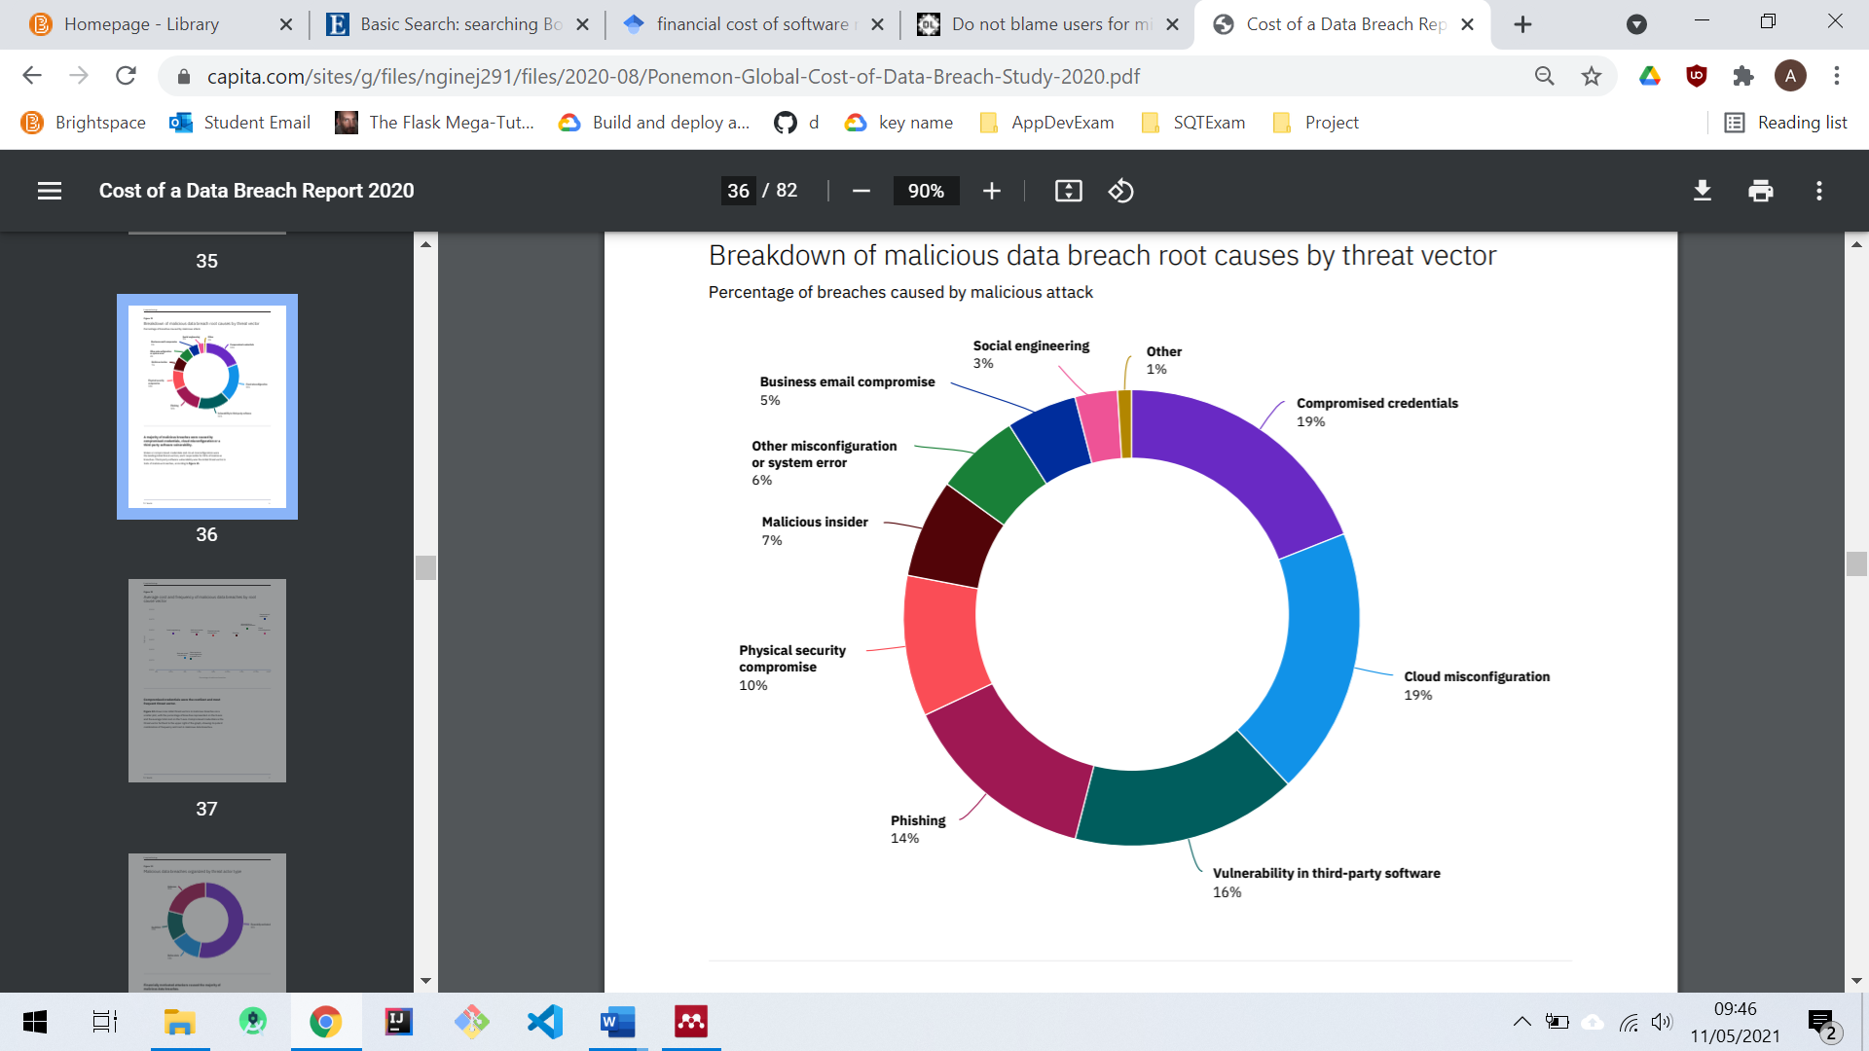

Figure : Percentage of breaches caused by malicious attack (IBM Security 2020)

## Development Team Considerations

### Environmental Consistency

Consistency across environments can prove very valuable for development teams. If a development environment is a direct replica of a production environment, then the team have a greater level of assurance in deploying changes into production. Collaboration is vital in maintaining consistency across environments. Distributed development presents a compelling case to make software development tools and environments more collaborative (Sengupta et al. 2006). The design of the artefact should therefore ensure visibility of environments so consistency of configuration can be monitored.

### Accountability

Development teams must take accountability for failures which originate with them however there can be significant barriers to achieving total accountability. Nissenbaum (1994) outlines that barriers to accountability include the theory that computers and software are developed in large organizations, bugs are considered a fact of life, there is ownership without liability, and the fact that computers are too often blamed for problems that are caused by human error.

A culture of accountability encourages high performance and with teams expressing accountability for failures, organisations encourage a high-performance culture through openness and honesty. Nissenbaum (1994) supports this, stating that a community (a society or professional community) that insists on accountability, in which agents are expected to answer for their work, signals esteem for high-quality work, and encourages diligent, responsible practices.

Accountability is an important concept in the artefact. Development and operations teams should hold collective responsibility for their environments, and the artefact can help ensure that development teams remain accountable in-to the deployment phase of a project.

## Literature Review Conclusion

The modern landscape for development teams points towards a DevOps centric culture with a key focus on accountability and a culture of collaboration, openness, and honesty. As organisations continue to drive towards this cultural shift, one of the key considerations is tooling to support this culture. While there are currently a multitude of DevOps monitoring tools available, an opportunity exists for a tool which supports the development team and leverages the application specific knowledge held within the team to identify the root cause of issues before they become public and risk the reputation of the organisation. The consistency of environments is also vital in order for development teams to remain in control and avoid unnecessary failures. The artefact offers an opportunity to improve visibility of environments and aid communication across teams. As outlined in 2.2.1, reputational impact can prove devastating for organisations so any measures which can be put in place to mitigate these risks will prove advantageous.

# METHODOLOGY

The selection of an appropriate methodology is key to the success of delivering the artefact. This chapter outlines the selection of an appropriate methodology along with the criteria used in the selection process.

## Methodology Selection

Before undertaking any software project, it is important to define a clear methodology and plan for creating the final product. This section discusses selection criteria for choosing an appropriate methodology and the strategy adopted to deliver the artefact in a structured and professional manner.

### Selecting a Methodology

The criteria in Figure 3 have been defined to ensure that the methodology has been selected with specific consideration for the needs of the project:

|  |  |
| --- | --- |
|  | **Criteria** |
| **1** | Scope for adjusting requirements if necessary |
| **2** | Creation of working prototypes at regular intervals |
| **3** | Project delivered by an individual developer |
| **4** | Regular reviews on an individual basis |

Figure : Selection Criteria for Methodology

The above criteria have been chosen to facilitate an individual project; therefore it was important that regular feedback could be attained to provide a differing perspective on the artefact. While the requirements for the project can be derived through modelling and are informed by personal experience, it was important to ensure an element of flexibility was available to revisit the requirements.

### Methodologies Considered

The project has been undertaken with a hybrid methodology based around Prototyping and Kanban. The three methodologies considered for this project were Prototyping, Kanban and Scrum. All methodologies have been considered based the criteria identified in Figure 3 with the following observations informing the decision to proceed with a hybrid approach:

#### **Prototyping**

Prototypes are useful for formulating and validating requirements, resolving technical design issues, and supporting computer-aided design (Kordon and Luqi 2002). Prototyping facilitates iteration and refinement through the building, testing, and reworking of a prototype and can allow refinement of a complex design. Prototyping can help extend and refine a design. It does not replace thinking through your design concept, but sometimes, the purpose is to come up with new concepts and simply explore (Arnowitz et al. 2007). Prototyping therefore allows for constant iteration and encourages a strong design process however offers the flexibility to refine a design to meet the requirements. This iteration will be key in delivering the artefact as while the requirements may be quite clear, it is important that designs can be revisited to deal with technical challenges.

#### **Kanban**

Kanban is a popular framework used to implement [agile](https://www.atlassian.com/agile) and [DevOps](https://www.atlassian.com/devops/what-is-devops) centric software development. It requires real-time communication of capacity and full transparency of work. Work items are represented visually on a Kanban board, allowing team members to see the state of every piece of work at any time (Atlassian, 2021). Kanban ensures constant visibility of workloads via a Kanban board and ensures that project timescales remain in plain sight. The focus throughout is around delivery of individual features which are tracked throughout their progression. Kanban offers simplicity, focus on the flow of work and no obligatory iterations (Ahmad et al. 2013).

#### **Scrum**

Scrum describes a set of meetings, tools, and roles that work in concert to help teams structure and manage their work (Atlassian, 2021). A Scrum based approach is focussed on a team environment and while Scrum offers the benefit of providing an iterative approach, it does not fulfil the criteria defined for this project and is unlikely to add value in an individual project.

### Chosen Methodology: Hybrid approach- Prototyping/Kanban

The chosen approach was a combination of Prototyping and Kanban. The building of the artefact is an individual project which has clearly discernible requirements however, in delivering the requirements there were several technical challenges which had the potential to require a revisiting of design documentation.

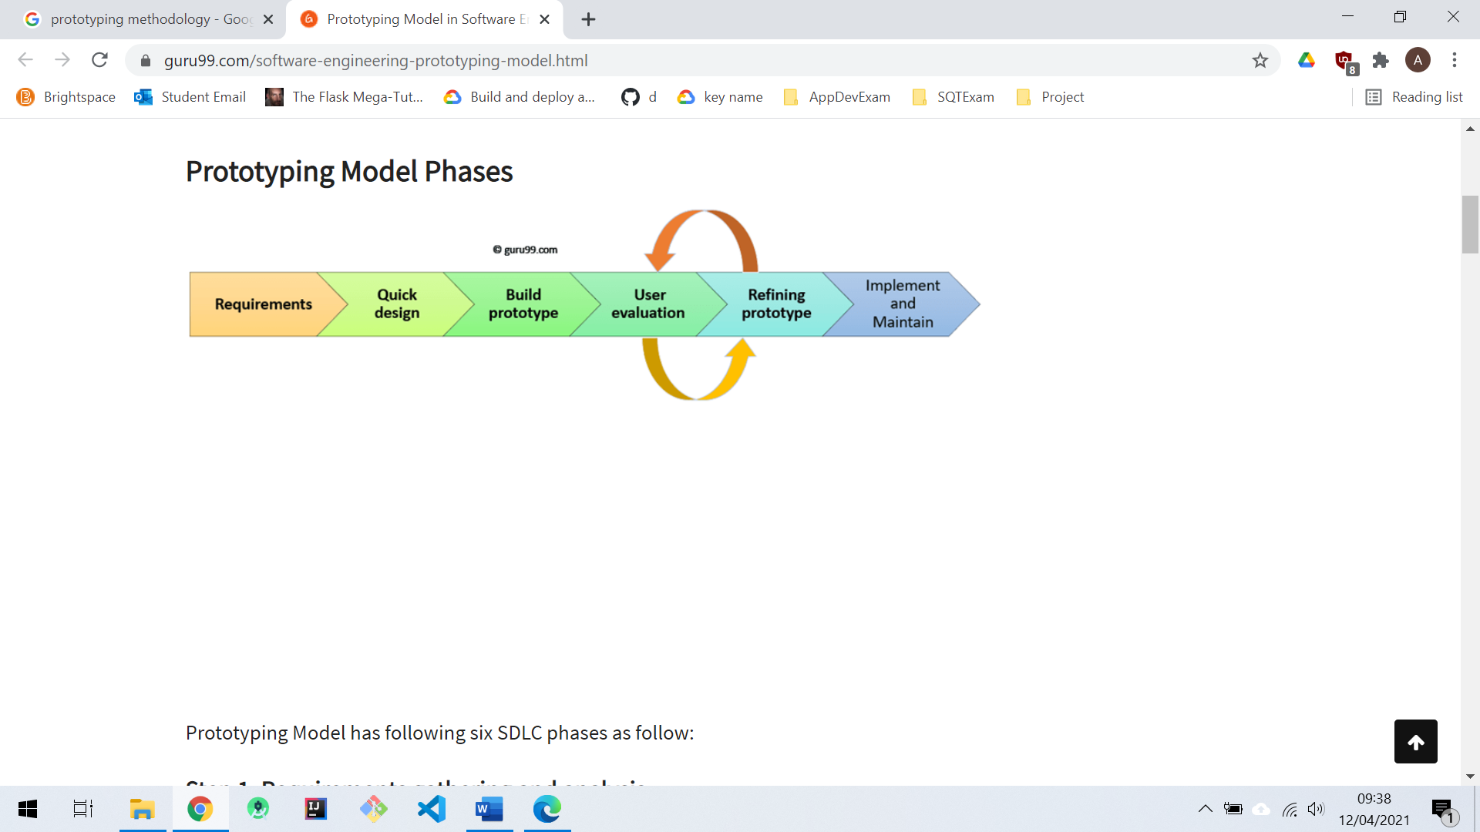

Figure : Prototyping Model (Guru99, 2021)

In selecting Prototyping as a methodology, the project was afforded the flexibility to revisit designs where necessary to solve technical challenges. Figure 4 outlines the iteration available within the prototyping framework. In combination with prototyping, Kanban also afforded the project the ability to track features and requirements effectively throughout. Figure 5 outlines the Kanban board which has been adopted to track requirements defined in Appendix F.

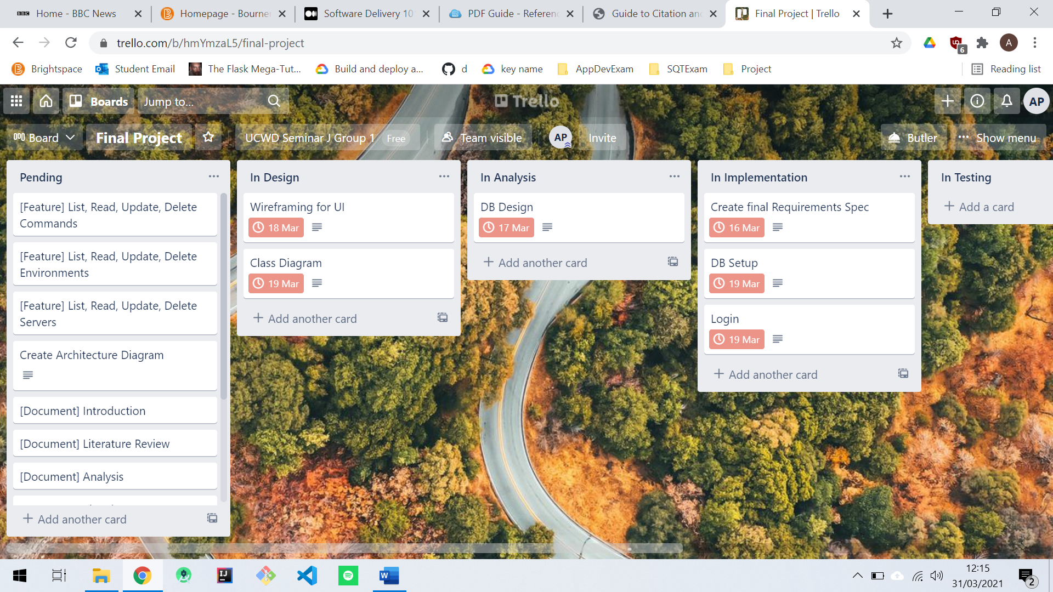

Figure : Kanban Board

Kanban offered the benefit of facilitating unexpected work items throughout the project. There is a level of flexibility with a Kanban based approach that allows for unforeseen work items to be added to the project board, therefore ensuring that items remain visible, and timescales can be adjusted, dependent on workloads.

## Planning

The planning phase of the project involved planning how the artefact would be delivered and put in place a process to be followed in delivering the artefact. This section will outline the methods used to keep track of the milestones associated with the project as well as techniques for estimation and prioritisation of workloads throughout.

### Gantt Chart

The use of a Gantt chart alongside the Kanban board ensured that I gained higher level visibility of the project milestones. The Kanban board provides a live overview of the specific tasks within the project however the Gantt ensured that the overall milestones of the project remained on track. A revised Gantt chart has been attached at Appendix E which provides an outline of the timescales achieved in delivery of the project. As issues were encountered throughout the project the Gantt chart acted as an opportunity to readjust the high-level milestones of the project.

### Estimation

To predict the timescales associated with delivering the artefact, a time-based estimation has been included at Appendix G which allowed me to make an overall prediction on delivery of the project. These estimations have been based on previous experience with the technology involved in the delivery of the requirements and have involved a level of intuition in predicting the level of effort required. It is challenging for developers to provide a high level of accuracy in estimation. In the case of development schedules, many programmers find it self evident that accurate and objective estimates are not possible (Lewis 2001). It is however important to provide an estimate and understand any challenges encountered in achieving the target.

### Prioritisation

Alongside the use of a time-based estimation technique, a prioritisation strategy has also been adopted guided by the principles of MoSCoW Prioritisation. The requirements defined in Appendix F have also been categorised based on priority as one of the following:

* Must have- Key feature for the application to fulfil its requirements
* Should have- A feature which may elevate the base functionality of the application
* Could have- A feature which would prove desirable
* Won’t have- A feature which may prove useful in future versions, but not currently required

The specific use of Must Have, Should Have, Could Have or Won’t Have provides a clear indication of that item and the expectations for its completion (Agile Business Consortium, 2020).

### Evaluation of the Solution

The final evaluation of the artefact will be based around a number of metrics produced throughout the project, which will allow a period reflection based upon items defined throughout the process of delivering the project. The following items will be used in evaluation of the final project:

* Original aims and objectives of the project
* System requirements
* Time estimations updated following completion of the artefact
* Design documentation
* Methodology selection

In evaluating the project these items will provide a benchmark upon which to assess the success of the project. The original aims and system requirements will inform the success of the delivery of the minimum viable product. Taking a reflective review of the time-based estimations will offer an insight into the success of the planning process with a review of technical designs informing both the success of the design and implementation of the artefact.

# ANALYSIS

Following on from methodology selection, this chapter will outline the process of analysis undertaken in delivery of the artefact and has been informed by the research undertaken in the literature review. This chapter includes the elicitation of requirements and the analysis undertaken to support delivery of the requirements.

## Requirements

Requirement’s elicitation tries to discover requirements and identify system boundaries by consulting stakeholders (Forbrig 2016). The final requirements specification has been derived from personal industry experience with scripting solutions as well as through discussion with fellow developers and infrastructure engineers in conjunction with the research undertaken in the literature review. The artefact itself had some key requirements which are centred around the ability of users to execute commands across multiple servers within an environment. A minimum viable product (MVP) has been defined alongside an MVP+ which aims for a more extended level functionality. This section also outlines the process of arriving at the requirements specification attached at appendix F.

### Requirements Elicitation

In eliciting requirements, it was important to ensure that the requirements were achievable within the specified timeframe. In this case, requirements were created, which directly correlate with deliverable features in producing the application. With clearly defined features, this in turn informed the branching strategy to be adopted in Version Control. Figure 6 identifies a sample of git branches which map directly to the requirements specification and also the Kanban board for the project. This ensured traceability of work items throughout the project.

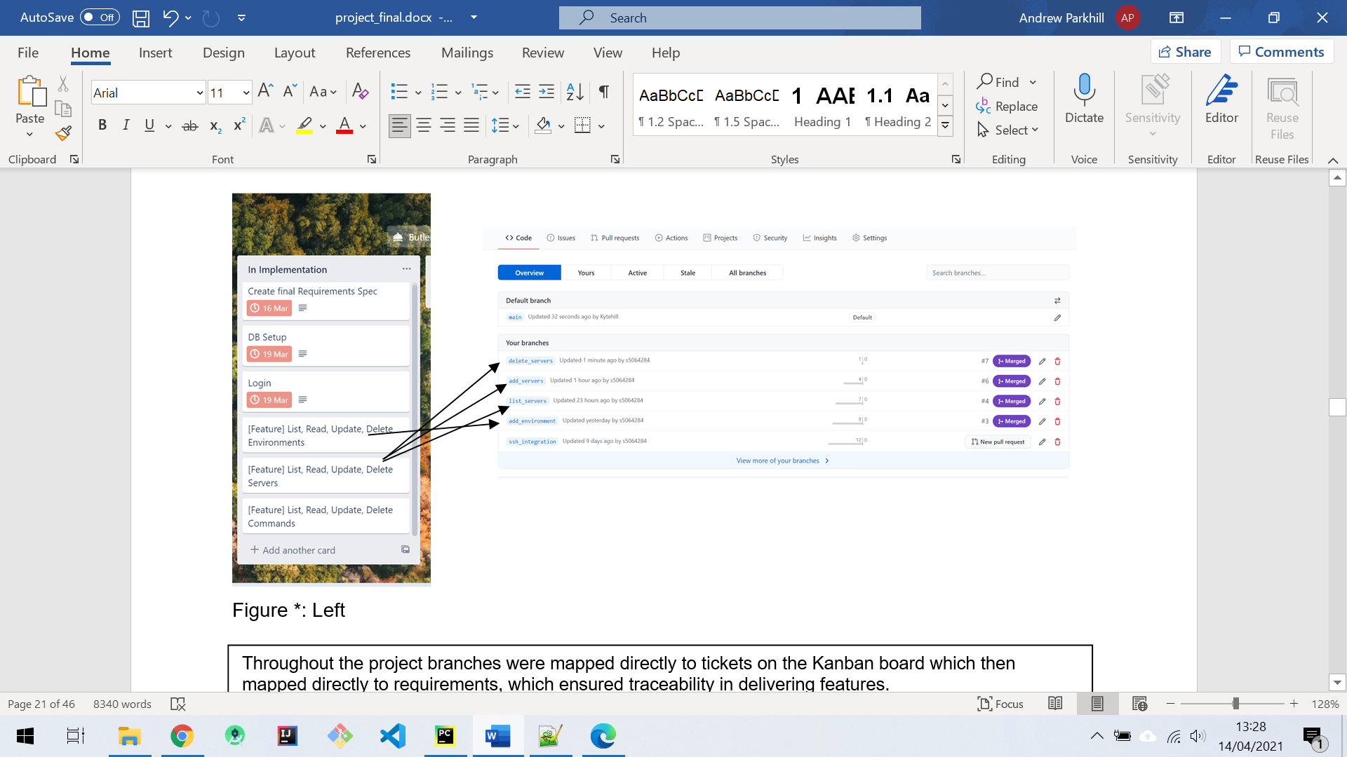

Figure : Features on Kanban board map directly to branches in Git <https://github.com/Kytehill/habitat/branches>

### Minimum Viable Product

The concept of an MVP is often utilised in start-up companies. An MVP allows the organisation to increase productivity quickly with the goal of gaining feedback to inform future development. One of the most effective ways to create MVPs is by prototyping the experience (Gothelf and Seiden 2017). In a time limited project such as this, it was important to set achievable objectives, so the MVP has been defined with this in mind. Appendix F outlines the requirements defined for the MVP as well as requirements for an extended version of the application (MVP+). In defining the MVP, I ensure that a demonstratable proof-of-concept is achievable while also considering requirements for extended functionality which can be added if achievable within the timeframe.

The MVP defined aims to provide a level of functionality which will allow users to run a series of Linux commands across multiple servers and to identify if the outputs from the commands match an expectation which has also been set by the user. The MVP will also offer visibility of the pass/fail status of command execution on servers and also at an environments level.

# DESIGN

Following the analysis phase, the project moved into the design phase. At this point the requirements had been finalised and the project moved on to the more technical aspects of the design for the artefact. The design focussed on the structure of data required to deliver the application while remaining considerate of the user’s needs.

## Modelling

In designing the artefact, it was important to gain visual representations of the system. In achieving this I adopted a series of modelling techniques. The use of models has provided the opportunity to gain a deeper understanding of the technical implementation of the system.

### Use Case Modelling

To develop a high-level understanding of how users will interact with the system I have undertaken an exercise in Use Case Modelling (see Figure 7) which allowed me to create a visual representation of the system from a user’s perspective. It is important to consider security from the outset so within the use case model it was also important to consider the actions of a potential malicious user. This offers the opportunity to pre-empt any potential security breaches. Use case modelling provides an excellent platform for visualising system requirements and puts a developer in the mindset of the user which is an excellent perspective to utilise in understanding specific use cases associated with the requirements and also allowed me to take a risk-based approach.

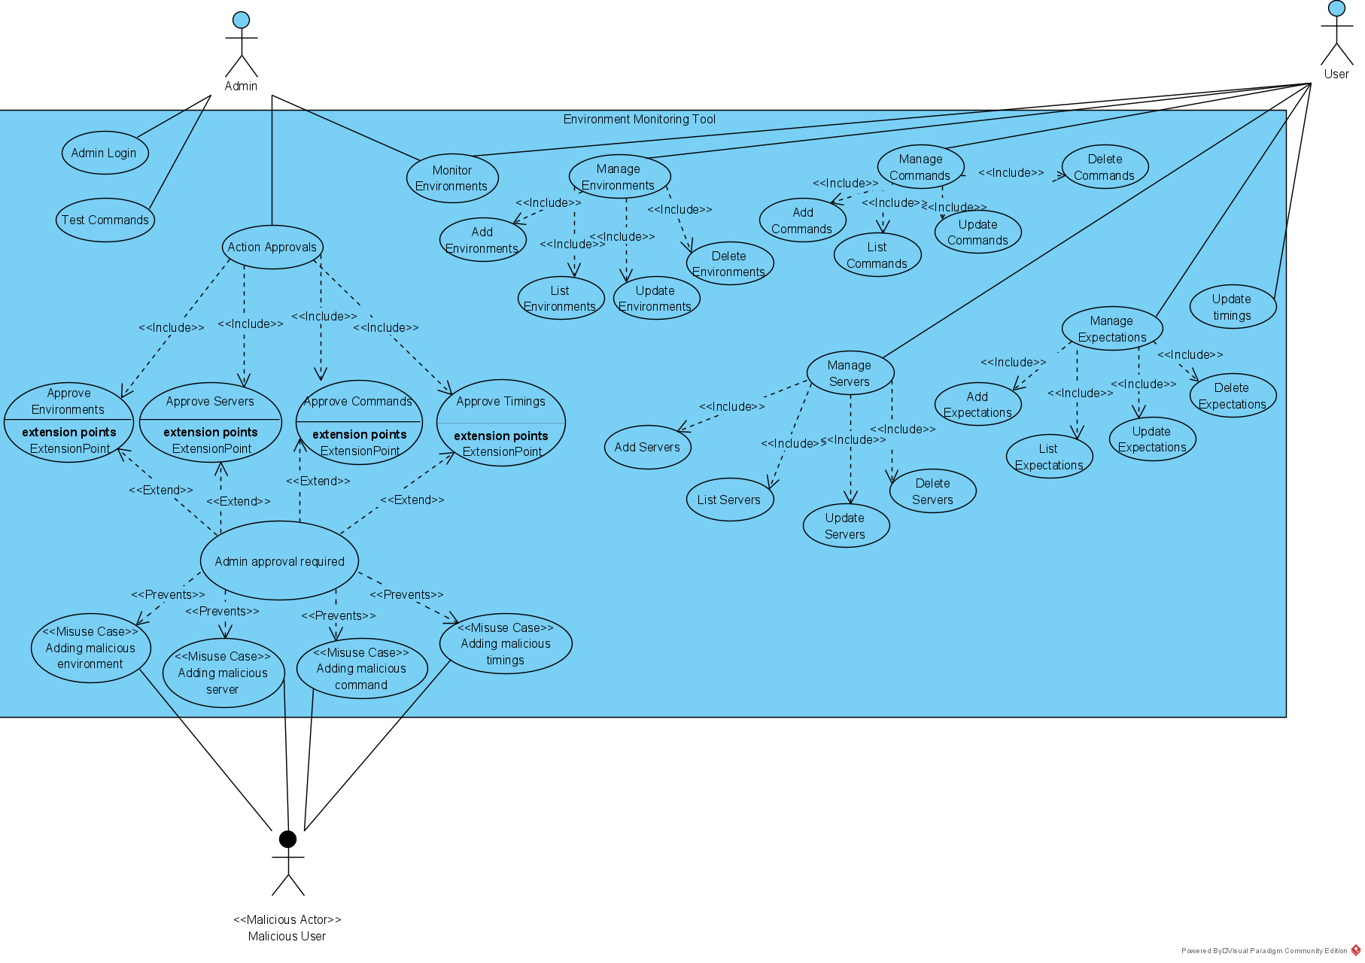

Figure : Use Case Model

### Database Design

The chosen database for the artefact was a relational database and was delivered with a combination of SQLite and SQLAlchemy. Further justification of these choices has been provided in section 5.3. The database design diagram in Figure 8 provides an outline of the tables required in the artefact as well as the relationships between tables.

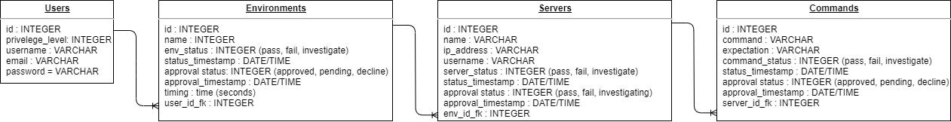

Figure : Database Design

The tables defined map directly to the objects in the program which have been derived directly from the system requirements. The user will have visibility of command execution at three levels; commands will execute on a specified server, with servers then sitting within a specified environment with users defining environments. The relationships defined in Figured 8 offer a visualisation of the data structure.

## User Interface Design

The user interface (UI) provides the interface between the application and the user. The design of the UI should therefore be considerate of the end user. Everything stems from knowing your users, including understanding their goals, skills, preferences, and tendencies (usability.gov 2021). While the artefact is aimed at a target market of Software Developers, it remains key to consider their needs and provide a simplistic interface to interact with the application. The end user of the artefact will only engage effectively with the solution if they are provided with an intuitive and easy to use interface, without this, the artefact risks being unsuccessful in achieving its objective.

### Bootstrap

As a relatively inexperienced UI developer it was important to leverage as much support as possible in this area. Bootstrap provides a framework for developing a UI which ensures consistency across browsers. Ensuring such consistency could prove a significant technical challenge so the use of a framework such as bootstrap allowed me to increase productivity. While Bootstrap proved advantageous in this case, there were also drawbacks to be considered. Bootstrap applications can all have a similar look and feel which may be perceived as a lack of creativity in UI development. There is also a learning curve associated with Bootstrap, however having previous experience with the framework ensured this did not impact productivity.

## Design Decisions

Any software engineering project will face a series of decisions around the designing of the solution. Some of these decisions will be fundamental elements such as the programming languages or data structures required while others will be unexpected and only unearthed as the project progresses. This section outlines the key decisions taken throughout the delivery of the project.

### Linux

The design of the application is centred around the execution of commands in Linux environments. The decision to focus on Linux devices was taken based on the popularity of Linux devices in providing server provision as well as personal experience in the use Red Hat Enterprise Linux devices. Figure 9 displays the dominance of Linux devices in non-paid deployments as well as a significant market share of 33.9% achieved by Red Hat.

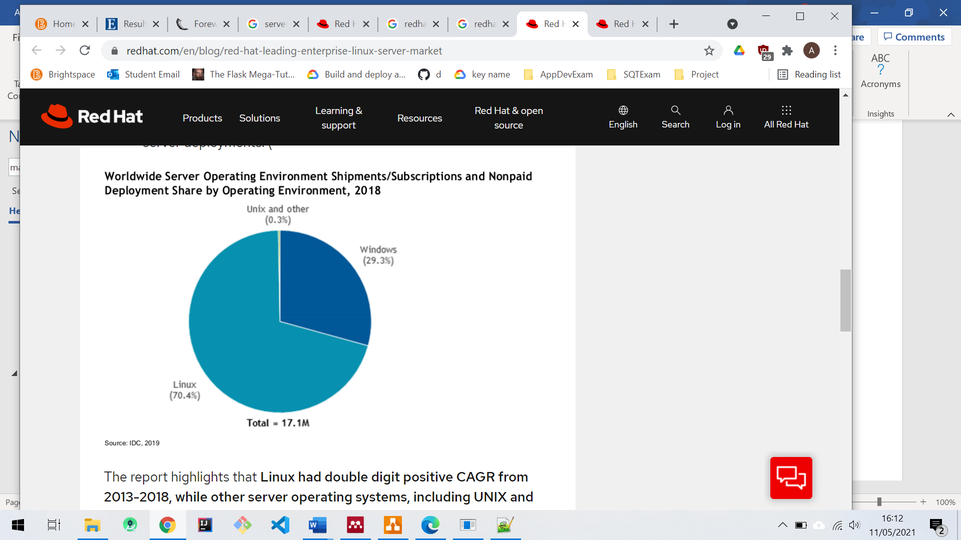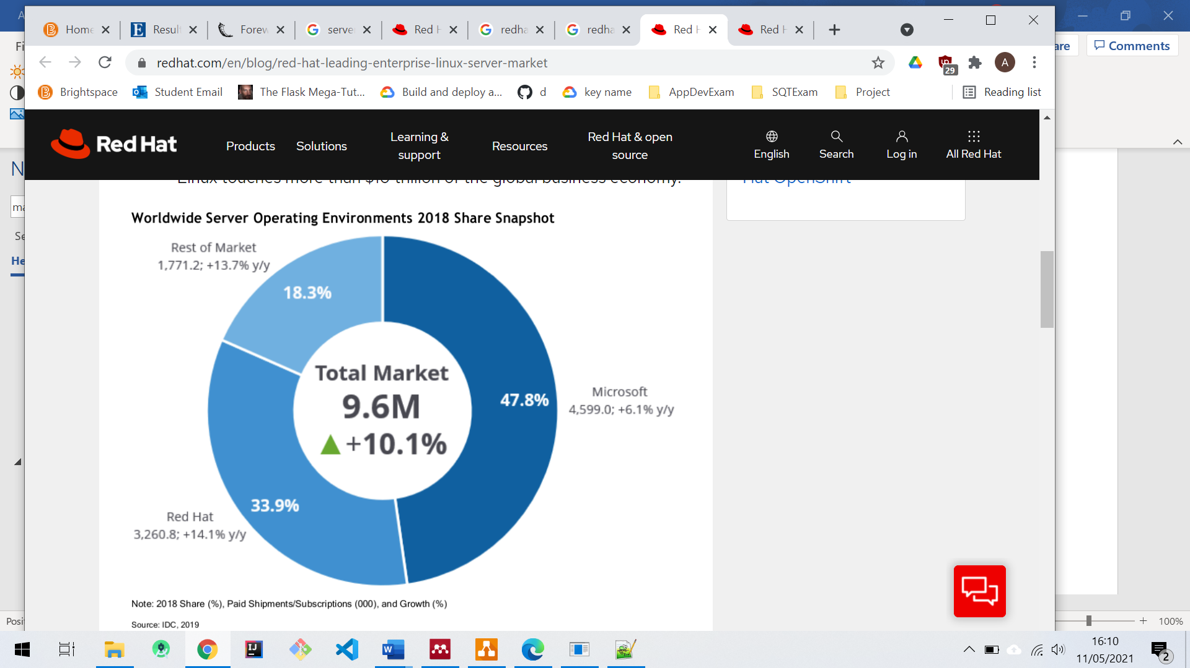

Figure : Red Hat/ Linux Market Share (Red Hat, 2019)

### Programming Language Selection

The first challenge was to identify a programming language to facilitate the artefact. Python’s worldwide popularity has increased massively in recent years. The Popularity of Programming Index outlined in Figure 10 identifies that Python is currently the most popular language based on

analysis of how often language tutorials are searched on Google. This gives a clear indication of the popularity of Python.

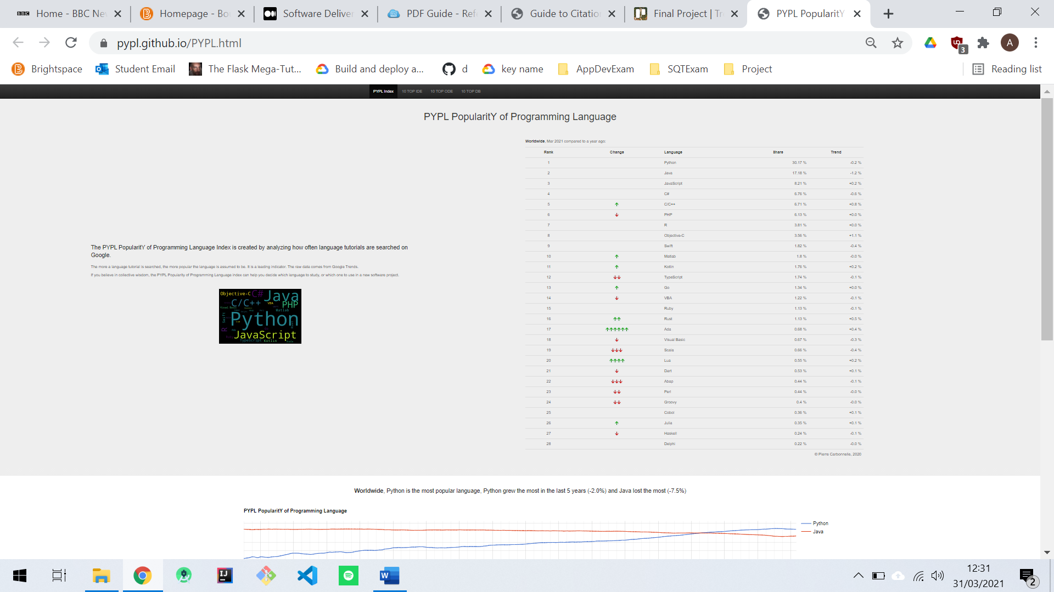

Figure : Popularity of Programming Languages (PYPL 2021)

In considering which language to utilise in this project, I approached the decision having experience with both Java and Python. Figure 6 below outlines some key features of the two languages.

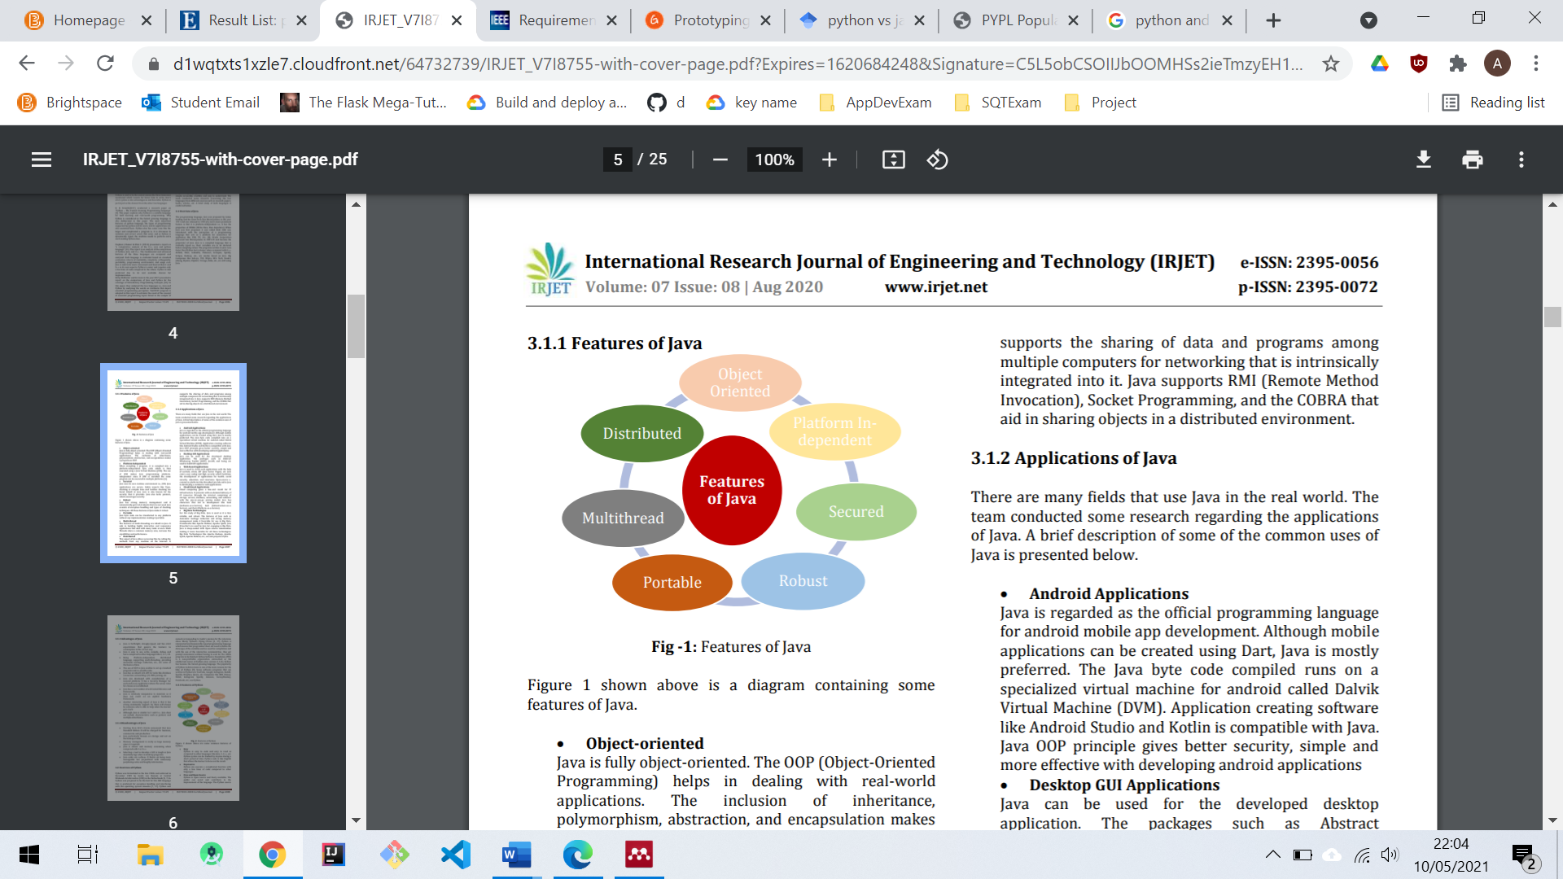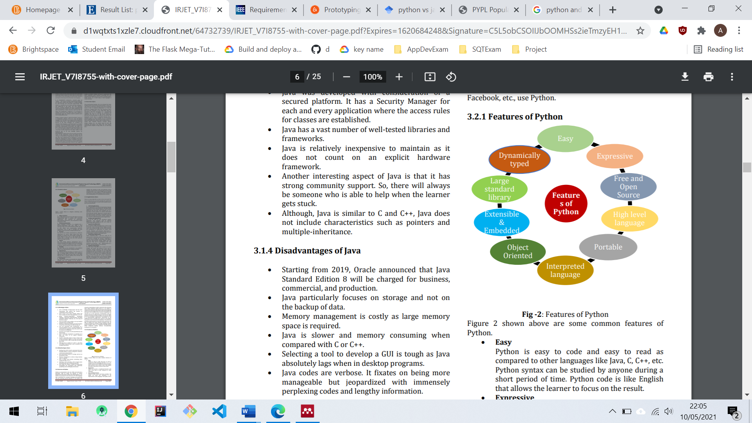

Figure : Features of Java and Python (Khoirom et al. 2020)

Python was the final choice with its ease of use proving an attraction for a relatively inexperienced developer as well as offering object-oriented capabilities. In reaching the decision to proceed with Python, it was also important to consider dependency management. Python offers a “Virtual Environment” which provides a Python installation which is local to the application. Upon activation, any third-party dependencies which are installed will be packaged locally with the application, meaning that the dependencies of each application remain self-contained and are not installed globally. This ensures that issues are not encountered when working across multiple projects

### Frameworks

A software framework is an abstraction layer that provides software libraries that offer solutions for most common programming problems (Vuksanovic and Sudarevic 2011). There are a wealth of frameworks available across most programming languages and while frameworks can provide advantages through set standards, consistency and predictability as well as offering thoroughly tested libraries, there can be drawbacks with strict conventions hindering flexibility and creativity as well as an often steep learning curve (Vuksanovic and Sudarevic 2011). In the case of the artefact it was deemed that the consistency offered outweighed the difficulties in learning a framework so I chose adopt a Python framework in the development of the application.

### Framework Selection

The two most prominent frameworks in Python are Flask and Django, as outlined in Figure 13. Both are mature frameworks, so it was important to consider both options in the development of the artefact.

Flask is a microframework with the ability to scale up into more complex applications. The “micro” in microframework means Flask aims to keep the core simple but extensible (Pallets Project 2021). As a framework I had some previous experience with Flask, and was aware of its simplicity, particularly for beginners. Flask is also packaged with a built-in development server which allows for very effective debugging. While Flask provides a very simple and effective development environment, it does also come with inherent drawbacks in that Flask as a framework does not hold strict conventions, which can prove problematic for inexperienced developers. Flask offers suggestions but does not enforce any dependencies or project layout. It is up to the developer to choose the tools and libraries they want to use (Pallets Project 2021). Frameworks which provide a more enforced structure such as Django provide a clear convention which means that there is a clearly defined path which ensures the framework is used as it was originally intended.

|  |  |
| --- | --- |
| **Django** | **Flask** |
| Provides in built features including ORM | ORM not in-built, installed from third party |
| Offers templating | Offers templating |
| Better for more standard web applications | Better for more custom architecture |

Figure : Django and Flask Comparison

On the balance of the research conducted I concluded that Flask was a more favourable option in providing a level of flexibility for a relatively inexperienced developer, this decision is further enhanced by the Python Developers Survey outlined in Figure 12 which confirms Flask as the most popular Web Framework for 2020.

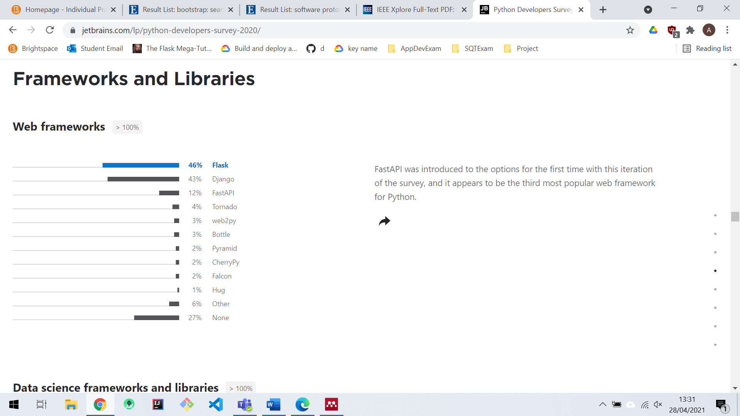

Figure : Python Developers Survey 2020 (Jetbrains 2020)

Additionally, Flask required the selection of an Object Relational Mapper (ORM) to provide an abstraction layer between the database and the application code which automates the transfer of data stored in relational database tables into objects that are more commonly used in application code (Full Stack Python, 2021). Following analysis, it was clear that SQLAlchemy was the widely accepted technology for providing an ORM in conjunction with Flask.

With the focus on creating a lightweight Flask application I chose to utilise a lightweight SQLite database. SQLite does not require any installation, and it is simple to run within a Flask development environment. One of the drawbacks with SQLite is a size restriction of 2GB, however this should not prove an issue for the data required in a lightweight application.

### Third Party Libraries

Flask as a framework does not enforce dependencies which provides a great deal of flexibility, however it does mean there is an increased reliance on third party libraries. One of the key libraries utilised in this application is Paramiko (Paramiko, 2021). Paramiko provides the functionality to establish a Secure Shell connection with a remote server. This is a key requirement in the application and leveraging this functionality from an existing and established library results in a direct time saving in building such functionality.

While the use of third-party libraries undoubtedly has its advantages, particularly in saving time, it is very important that the decision to make use of a specific library is taken with great consideration. It is important to investigate the library thoroughly and establish whether its capabilities meet your specific needs, and it is also important to ensure that any libraries are from trusted sources. The use of third-party libraries can introduce issues around security, so it is of paramount importance that any external libraries are thoroughly researched before implementing.

### Scalability

The artefact should facilitate monitoring of multiple servers across environments so with this in mind it was vital that scalability was a consideration in delivering the solution. The minimum viable product looks to display the functionality and capabilities of the system. A real-world use case for this system could see the application hosted on a landing server to monitor a large number of servers within a data centre. In consideration of this the MVP+ aimed to implement a multi-threaded approach to executing commands across servers. Multi-threading would allow execution the commands on separate threads which could improve the productivity of the application. An individual thread is created for each server and the relevant commands executed to monitor that particular server.

## Security

Security is an important consideration for any application. This artefact has the potential to connect with customer facing environments, meaning the risk associated with any attack are very high. This section will outline the decisions taken around security in delivering the artefact.

### Secure Shell Protocol

In order to establish a connection with a remote server, I had previous experience with use of the Secure Shell protocol between a client remote Linux devices. The SSH protocol uses encryption to secure the connection between a client and a server. All user authentication, commands, output, and file transfers are encrypted to protect against attacks in the network (SSH Academy 2021).

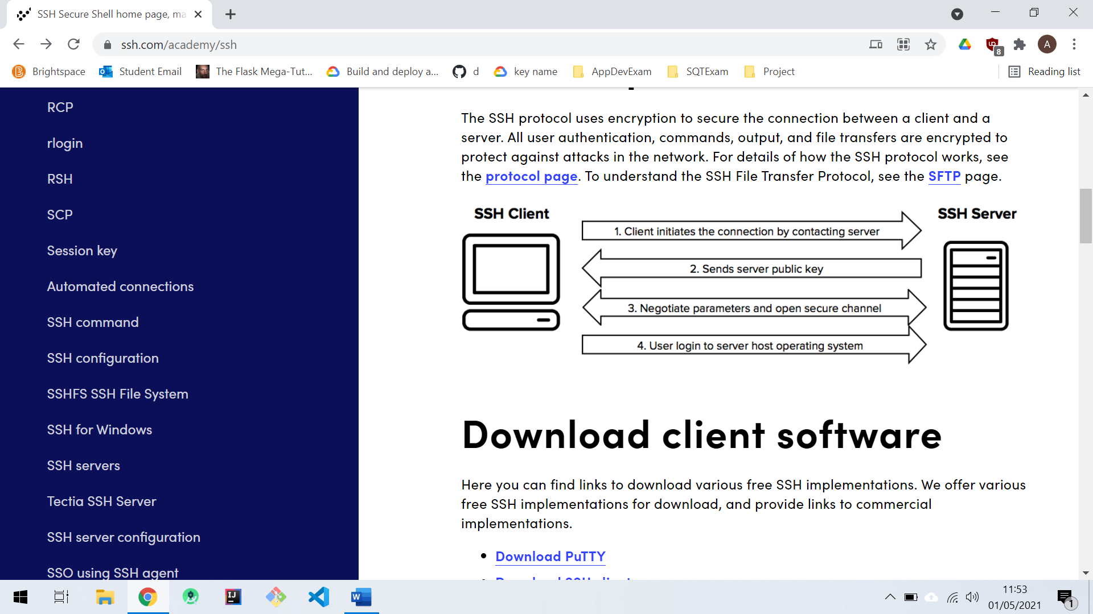

Figure : Secure Shell Connection (SSH Academy 2021)

Figure 14 provides a visual representation of the communication between a client and a remote server. This protocol along with the capabilities leveraged from Paramiko, outlined in section 5.3.5 ensure that multiple, secure connections can be established across environments along with the capabilities to execute linux commands.

### Flask and Security

One of the benefits of building the artefact with a mature framework in Flask is the availability of security features which are simple to implement. A significant amount of effort and expertise would be required for a developer to build and implement their own security features so having the ability to leverage tried and tested security features is of great benefit in terms of saving time and resource.

#### **Password Hashing**

Password hashing was achieved in Flask by leveraging Werkzeug which is a library which is native to Flask and available upon installation of the Flask framework. Werkzeug uses cryptography to create a unique hash of the password and each time the password is hashed it will create different results. Werkzeug also provides a verification function which verifies that the hashed password matches the user input. This functionality would be very complex and time consuming to build so it is a significant benefit that this native functionality is provided with Flask.

# IMPLEMENTATION

The implementation phase of the project looked to take the designs outlined in the previous chapter and put them in to practice. At this stage, decisions had been finalised around the technology and any frameworks to be used in the project. This chapter focusses on the technical implementation of the solution.

## Development Process

The process of developing the artefact involved learning some key new technologies which were fundamental to delivery of the artefact. While I held previous experience with Flask, there was a learning curve associated with understanding the operation of its key dependencies in SQLAlchemy and SQLite.

### Database

The development of the database involved the setup of SQLite as well as establishing the Object Relational Mapping (ORM) via SQL Alchemy. The mapping is provided by a series of models which map the data persisted in the database to a tangible format to be rendered in the front-end templates. The database design was implemented by creating the required tables in SQLite and establishing the relationships. These relationships are also reflected in the ORM. Figure 15 identifies the model for an environment which leverages SQL Alchemy from the import detailed in line 1 of code sample. Also detailed in Figure 15 is the table structure from SQLite which directly maps to the model.

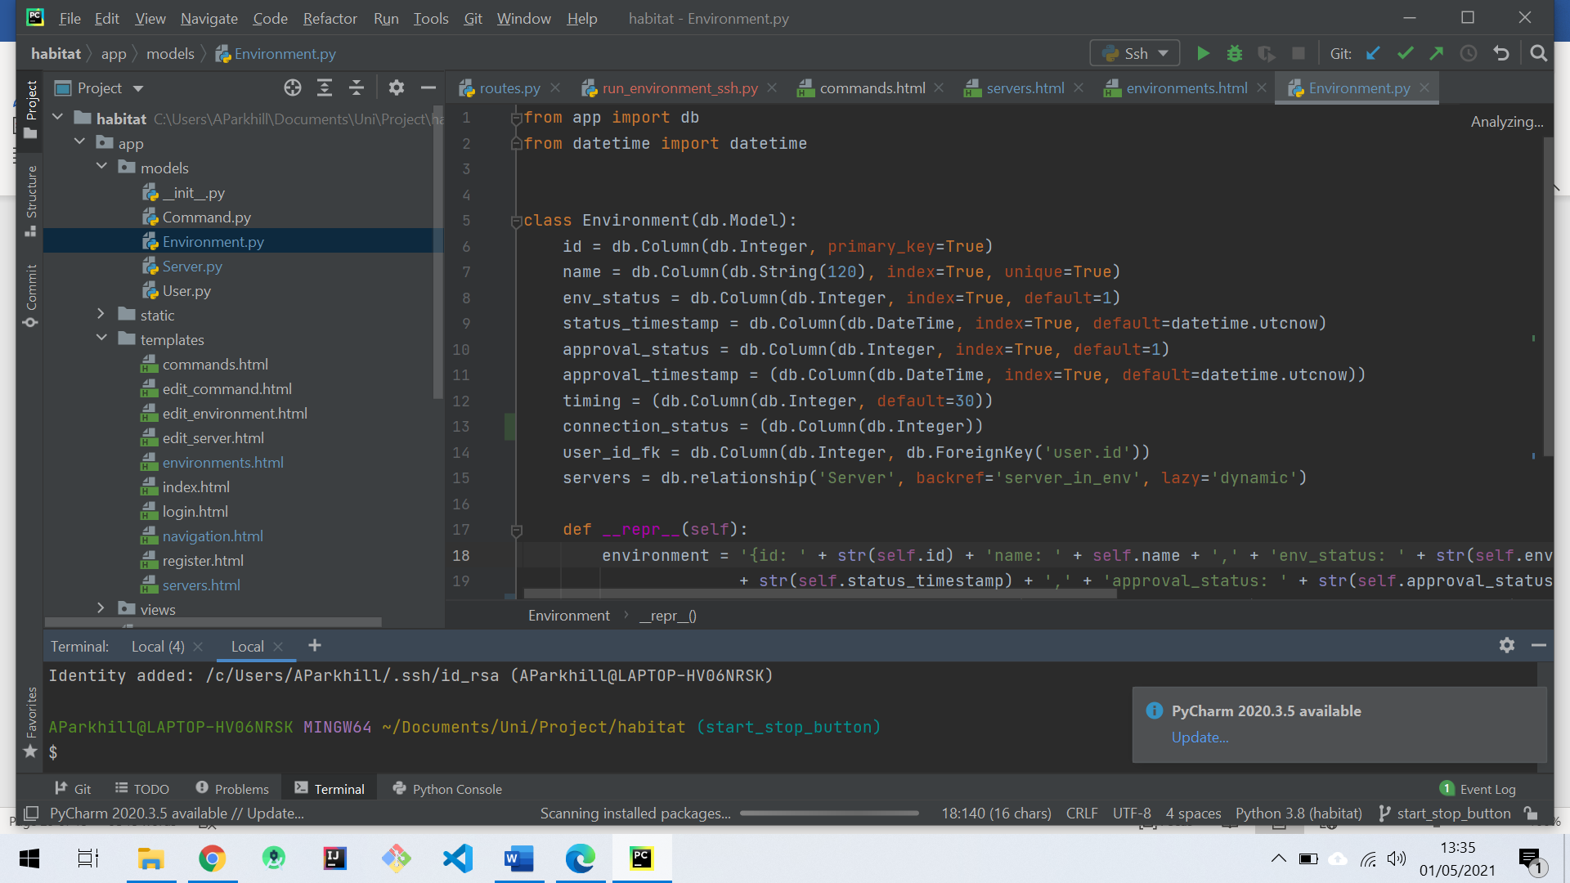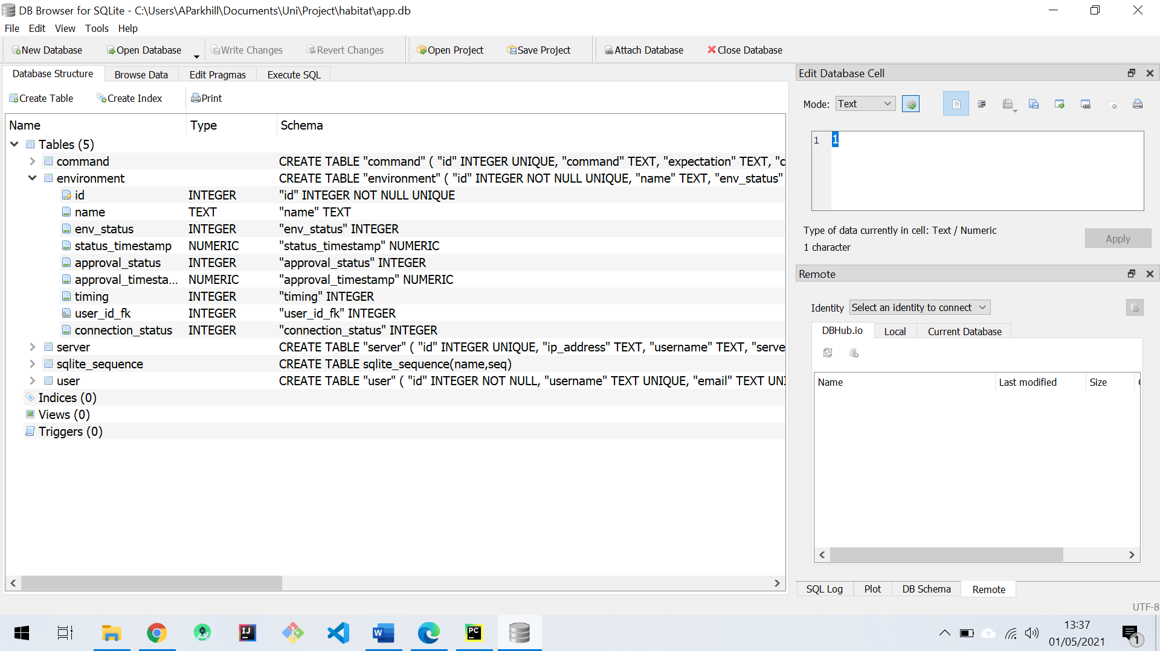

Figure : Right- Database structure in SQLite, Left: Database model for environment

### User Interface Development

Flask as a framework uses the concept of templates. Templates facilitate a series of separate HTML files stored within a “templates” directory. The use of templates allows for separation of the logic from the view rendered in the browser. Flask also utilises Jinja2 which is native to the framework. Jinjia2 substitutes blocks wrapped in “{{………}}” with values provided through the render_template() function and also facilitates conditional statements wrapped in “{%.........%}”. A sample of Jinja2 in use has been provided in Figure 16.

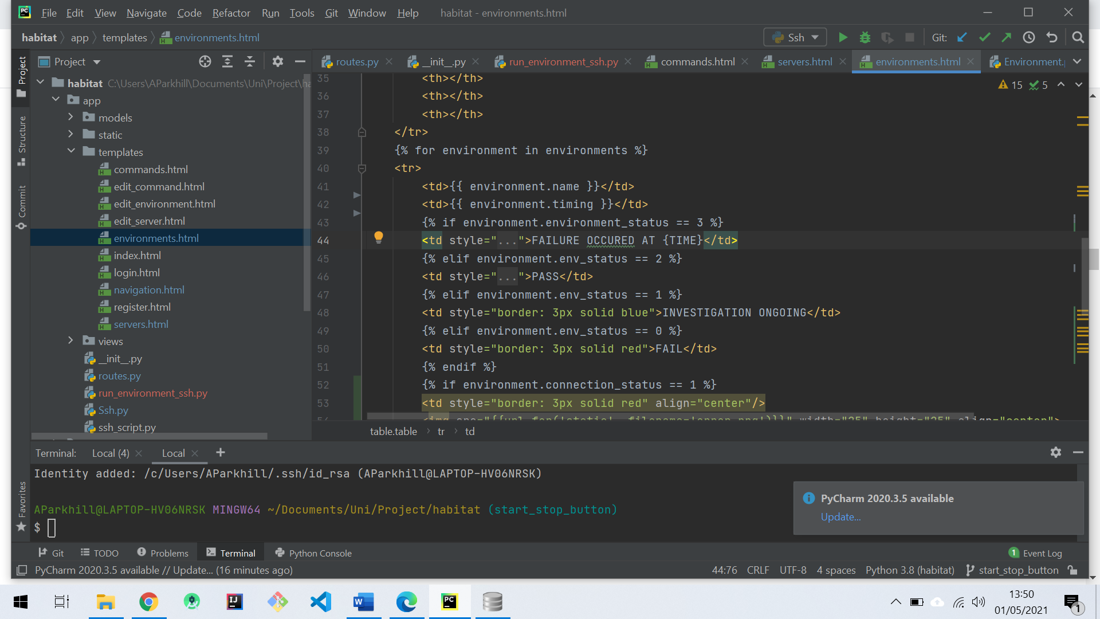

Figure : environment.html, outlining use of dynamic values and conditional statement provided by Jinja 2

Consistency in the look and feel of the application was achieved through the implementation of inheritance in the templates. A parent template in “navigation.html” provides the look and feel of the application which is then inherited withing the child templates throughout the application. Line 1 of the code sample provided in Figure 17 identifies the inheritance used to provide consistency across all templates.

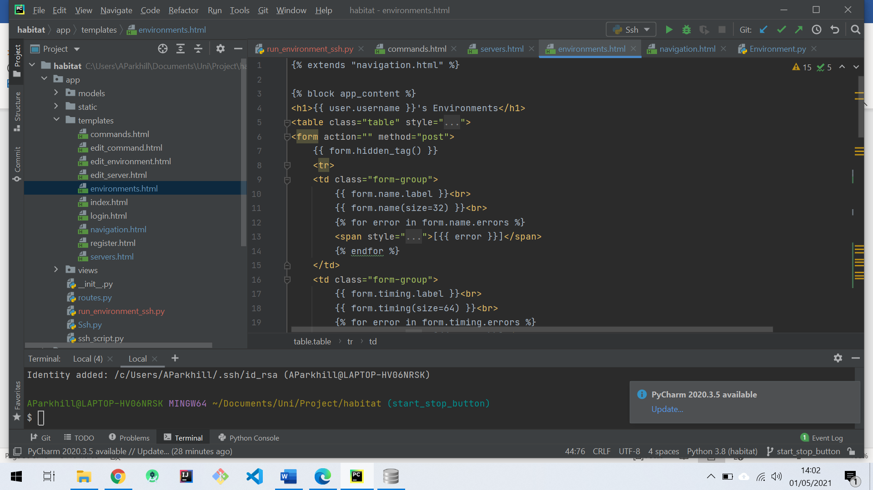

Figure : Code sample outlining inheritance used to provide consistent look and feel

## Development Tools

The tools associated with the development environment would support an efficient development process. The artefact had the added complexity of interacting with remote Linux devices, which meant that in addition to tools for Version Control and an appropriate IDE, virtual machines would also be provisioned alongside a physical Linux device facilitated with use of Raspberry Pi.

### Git

Version control is a fundamental tool in many software development projects. In the building of the artefact a git repository was set up at <https://github.com/Kytehill/habitat>. Using the functionality of git as a command line tool ensured that a branching strategy could be adopted which mapped directly to the specific tasks identified in the requirements. Git also assists in the process of debugging issues, by allowing the user to revert code to a previous point in time and identifying when and how issues may have arisen. By managing revisions, git allows a developer to select precisely which ones will comprise an integrated change, down to partial changes within a single ­file (Spinellis 2012). Software projects are complex and as Developers we can only carry a certain amount of cognitive load and Git offers developers the opportunity to break projects into chunks which are achievable and reduce cognitive load.

### Integrated Development Environment (IDE): Pycharm

Pycharm is an IDE provided by Jetbrains. Pycharm offers Python specific functionality which ensures that errors and warnings are clearly identified. Without use of an IDE such as Pycharm, a Developer could spend a significant amount of time debugging issues which can be identified prior to runtime by an IDE. Pycharm also assists in the use of virtual environments which are a python specific concept. Figure 18 outlines an example of Pycharm’s functionality in identifying an indentation error.

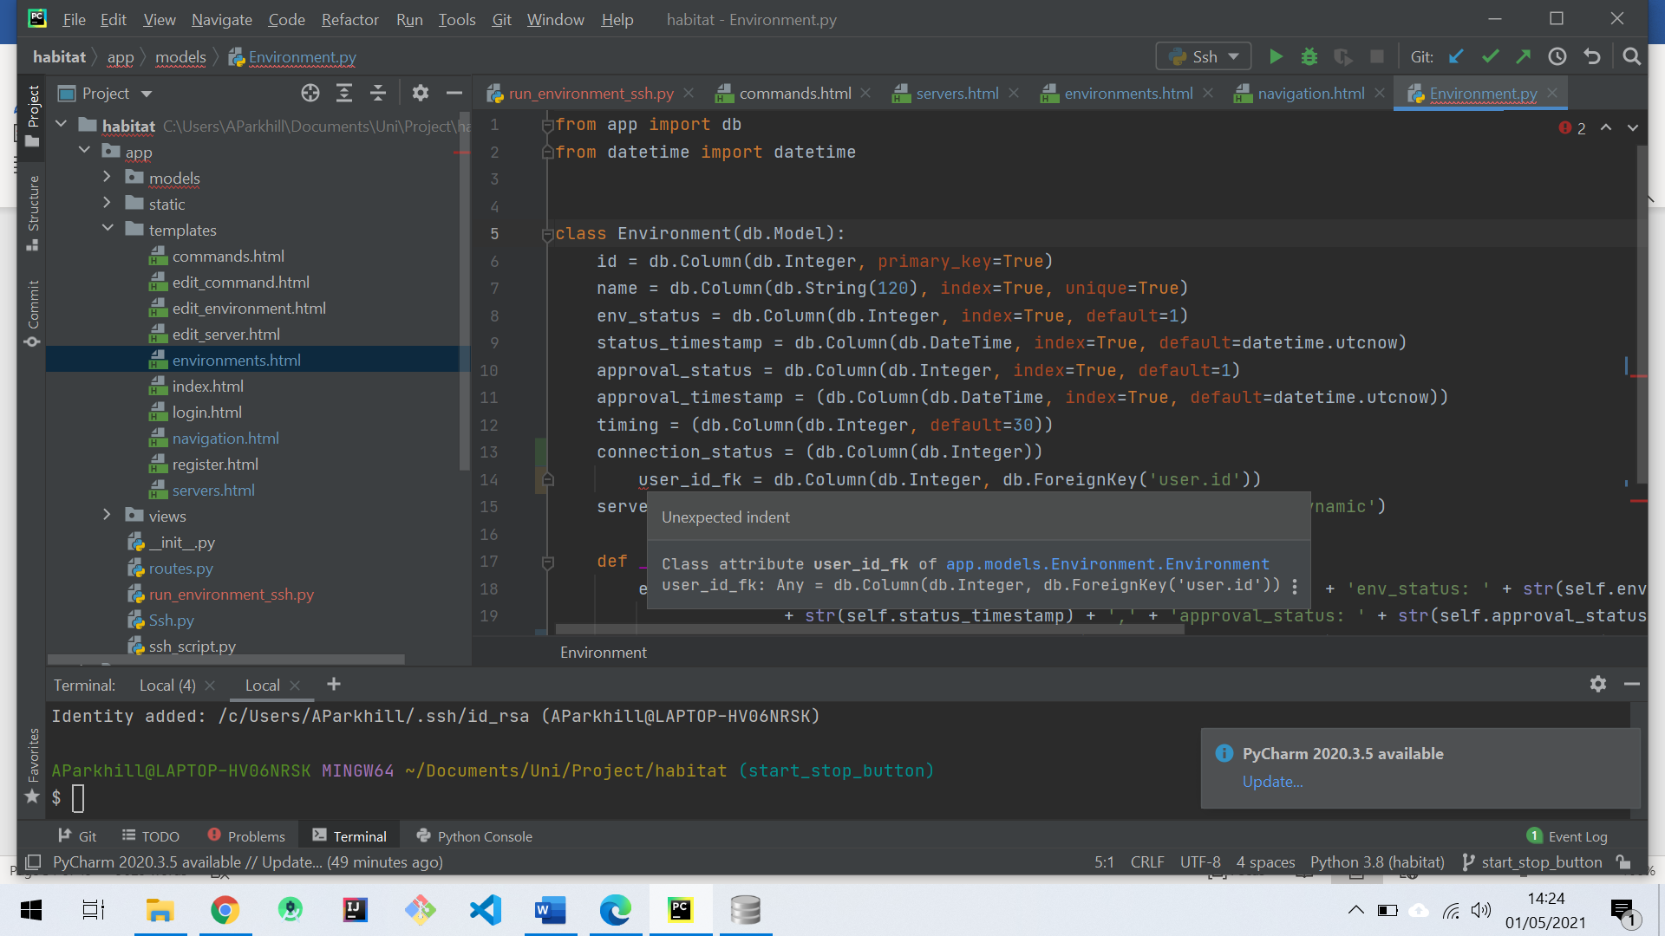

Figure : Functionality provided by Pycharm

## Architecture

Architecture is an important consideration for any application which requires access to highly secure environments. This creates a challenge, particularly when it comes to customer facing or production environments, these environments are often highly restricted, even for development teams, due to the high-risk nature of issues. This chapter outlines the recommended architecture for deployment of the artefact.

### Jump Server

In large organisations, applications are often deployed across multiple environments which can also be held within multiple data centres. In facilitating access to secure environments, organisations often adopt the concept of a landing server, also commonly known as a jump server which effectively acts as a window into the environment and may also monitor any actions taken within the environments. The individual landing server is identified as the control point. Within the context of this architecture the aim would be to deploy an instance of the artefact to the jump server for the environment it will be monitoring. This will ensure that the application has the relevant network access to monitor the necessary environment while remaining in the control of the team who control the jump server for that particular environment.

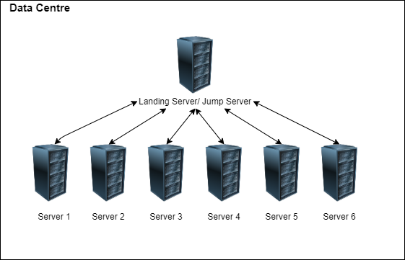

Figure : Jump server architecture diagram

# EVALUATION

Following implementation of the artefact, an evaluation process was undertaken. The evaluation was focussed around evaluating the quality of the artefact through testing as well as evaluating the final solution against the aims and objectives set out at the beginning of the project.

## Testing

The testing of the artefact was based around a series of functional test cases which have been derived directly from the requirements specification. These test cases have been executed alongside an element of exploratory testing. Exploratory testing was conducted throughout the development process in order to identify bugs on an ongoing basis. Any bugs encountered were then added to the Kanban board as active work items which could be considered in the overall delivery of the project.

### Quality

In producing a software artefact, it is important to consider quality. The quality of the artefact has been tested with the aim of achieving test cases which provide coverage for all requirements. The quality of the artefact itself also contributed to the quality of the testing output. If a product has high testability, it is easy to test and, consequently, easier to find bugs in (Whittaker 2000).

### Requirements

The process of testing the artefact was based around the satisfaction of the requirements. A series of functional test cases have been outlined in Appendix I which have been derived directly from the requirements specification and aim to test the functionality of the system. To accompany the functional testing, a combination of error guessing and exploratory testing also aimed to test the internal structure of the application.

### Defects

Defect logs have been outlined in Appendix J. These defects have been derived directly from the execution of test cases. It was important to consider traceability when identifying defects, to ensure that any fixes put in place are visible for any developers working on a project. The defect logs include a reference to the test case they have been derived from as well as linking to a branch on which the fix is made visible. This allows any developers working on the project to clearly track the fix, and ensures that any issues encountered with a fix will be easily identified.

## Evaluation of Aims and Objectives

The aims and objectives of the project were defined at the outset before any unforeseen circumstances were encountered and before overcoming any technical challenges. This section will reflect on those aims and objectives and provide a reflection on the success of their delivery.

### Research organisational impact of configuration failures

An in-depth review of literature was undertaken to investigate the organisational impact of configuration failures. This review identified an area with a wealth of research which has a real day to day impact on large organisations. The outcome of this review identified an area where tooling was of vital importance and where large organisation were constantly looking to improve communication through adoption of appropriate tooling. This review supported the justification for a web-based tool to assist development teams in the monitoring of environment configurations.

### Identify an appropriate methodology to complete all requirements efficiently

A combination of Prototyping and Kanban methodologies was selected for this project which overall proved a successful combination. Regular working prototypes were developed and the delivery of requirements were tracked using a Kanban board. Challenges were however encountered with this methodology in maintaining visibility of the overall timescales associated with the project. The overall timescales were tracked via a Gantt Chart however in practice this approach felt disjointed and quite challenging to maintain, particularly when the project was at its peak.

### Analyse problem domain and identify requirements for a Minimum Viable Product which provides a minimum level of functionality to prove the concept

The MVP defined at Appendix F proved to be an achievable level of functionality and proves the concept of monitoring configurations within Linux environments. There were however challenges encountered in the UI development as well as challenges in stretching to the requirements outlined in achieving the MVP+ functionality. These challenges have been further detailed in 6.2.4. The artefact does however prove that increasing the visibility of misconfigurations can be an advantage in intercepting production failures.

### Research the most appropriate technology stack to create the web-based solution

The combination of Flask and SQLite/SQLAlchemy proved successful in achieving the MVP however challenges were encountered in stretching to achieve the MVP+ functionality. Concurrency issues were encountered in the database when SQLite was combined with a multithreaded approach in the application. It also became clear that two separate processes would be required to execute commands across environments while flask delivers the web content. A task queue was identified as potential solution and will form the basis for future work in achieving the MVP+ functionality.

### Design the solution from technical perspective with appropriate modelling

The modelling phase of the project proved successful in achieving the MVP. Use case modelling proved very useful in deriving requirements with the user’s needs in mind. The database design proved sufficient in achieving the MVP however may need to be revisited to provide a more robust and extensible data structure. While the design has overall proven successful in delivering the MVP, there was a significant learning code associated with structuring the project in line with the Flask framework. This may learning curve may have been reduced with a more considered approach in understanding the structure of the project during the design phase.

### Implement the solution to meet the specified requirements with a focus on achieving the MVP

The final artefact achieves the requirements of the MVP. Issues were however encountered in achieving the MVP+ requirements as outlined in section 6.2.4. Work is also required to make improvements to the usability of the application. The expertise of a more experienced UI developer may benefit the project in future work in order to achieve a more polished User Interface. Code for the application is available from <https://github.com/Kytehill/habitat>.

Following implementation of the final solution, a review was taken of the timescales in achieving the MVP which is included in the “Actual Time” column in Appendix G. The actual time in delivering the MVP proved significantly more than anticipated. This mainly centred around the issues encountered with multithreading an concurrency however an underestimation of the learning curve associated with establishing an SSH connection with a remote device was also a contribution to discrepancy.

### Deliver of Aims and Objectives

Overall, I feel the aims and objectives of the project have been successfully achieved however key lessons have been learned around the pre-empting of technical challenges. Software development is complex, and the likelihood of encountering unexpected technical issues is quite high, so it is best to attempt to plan for this at the earliest stage possible, to provide a more accurate estimation on delivery.

# CONCLUSION

## Project Summary

The project as a whole has proven successful in achieving the MVP. The artefact provides a web-based application which provides the capability to monitor Linux configurations across multiple environments which can add value to development teams in reducing the manual intervention required to resolve issues as well as the manual scripting efforts often deployed to monitor environments currently. As mentioned in the evaluation section issues were encountered which have informed the future work outlined in section 8.2.

## Future Work

The next phase of this project should aim to add features which improve the usability of the application as well as providing an audit trail for the execution of commands in environments. An admin area could leverage the existing user sessions and provide an area for new environments to be approved before commands are executed, providing an additional layer of protection, which is particularly important in production environments. It is also clear a progress bar is required to inform users of progress during command execution. The next phase may also benefit from reviewing the database technology to facilitate concurrency alongside a task queue which would elevate the application to a more efficient solution. A further enhancement would also be the ability to setup SSH keys directly within the application, currently there is a prerequisite for users to set up SSH keys manually on the local and remote devices, adding this functionality to the application would provide a significant time saving for users. The parsing of more complex outputs from devices would also enhance the application. Currently the application will facilitate a single line output however in reality, complex environments may require the handling of complex multiline strings which may include URL’s or other complex string outputs, the use of regular expressions may assist in adding this capability.

## Evaluation of Issues

The main issues encountered with this project centred around the integration of the Secure Shell module. A significant amount of time was spent making attempts to deliver a multithreaded solution which executed commands on a long running background process. This time was not wasted, and a great deal was learned from the technical challenges faced, however with the benefit of hindsight it may have proved more beneficial to the overall project to proceed with a single threaded approach from an earlier stage. There were many positive learning experiences throughout the project, including a further development of knowledge in the use of Flask as well as first introduction to SQLAlchemy and SQLite. The project also offered an opportunity to take a project from concept, to a final delivered artefact, which proved an excellent experience in understanding the challenges associated with project management in the software industry. Overall, the project has proved a challenge and has provided the opportunity to learn valuable new skills and provide further experience within a software development lifecycle which will prove invaluable in industry.

Word count (main body of the report): 9,471

# REFERENCES

Agile Business Consortium. MoSCoW Prioritisation [online]. Available from:

<https://www.agilebusiness.org/page/ProjectFramework_10_MoSCoWPrioritisation>

[Accessed 28 April 2021].

Ahmad, M. O., Markkula, J., and Oivo, M., 2013. Kanban in software development: A systematic literature review. *Proceedings - 39th Euromicro Conference Series on Software Engineering and Advanced Applications, SEAA 2013*, 9–16.

Arnowitz, J., Arent, M., Berger, N., 2007. Effective Prototyping for Software Makers [online]. Elsevier Science & Technology.

Atlassian, 2021. DevOps: Breaking the Development-Operations Barrier [online]. Available from:

<https://www.atlassian.com/devops> [Accessed 24 February 2021].

Atlassian, 2021. Atlassian Agile Coach [online]. Available from:

<https://www.atlassian.com/agile/kanban> [Accessed 07 March 2021].

Atlassian, 2021, Atlassian Agile Coach [online] Available from:

<https://www.atlassian.com/agile/scrum> [Accessed 07 March 2021].

Carmel, E., Espinosa, J. A., and Dubinsky, Y., 2010. ‘follow the Sun’ workflow in global software development. *Journal of Management Information Systems*, 27 (1), 17–38.

CNN, 2015., CNN Business [online]. Available from:

<https://money.cnn.com/2015/07/08/investing/nyse-suspends-trading/> [Accessed 15 February 2021].

Computer World, 2012. IDG News Service [online]. Available from:

<https://www.computerworld.com/article/2493041/air-force-scraps-massive-erp-project-after-racking-up--1b-in-costs.html> [Accessed 03 March 2021]

Diel, E., Marczak, S., and Cruzes, D. S., 2016. Communication challenges and strategies in distributed DevOps. *Proceedings - 11th IEEE International Conference on Global Software Engineering, ICGSE 2016*, 24–28.

Dorairaj, S., Noble, J., and Malik, P., 2012. Knowledge management in distributed agile software development. *Proceedings - 2012 Agile Conference, Agile 2012*, 64–73.

Forbes Insights, 2014. The Reputational Impact of IT Risk. *Forbes* [online], 21. Available from: <https://www-935.ibm.com/services/multimedia/RLL12363USEN_2014_Forbes_Insights.pdf>. [Accessed 10 April 2021].

Forbrig, P., 2016. Continuous requirements engineering and human-centered agile software development. *CEUR Workshop Proceedings*, 1564, 1–6.

Gonen, B. and Sawant, D., 2020. Significance of agile software development and SQA powered by automation. *Proceedings - 3rd International Conference on Information and Computer Technologies, ICICT 2020*, 7–11.

Gothelf, J. and Seiden J. Minimum Viable Products and Prototypes [online]. O'Reilly Media

Guardian, 2021,. Technology News [online]. Available from:

<https://www.theguardian.com/technology/2021/feb/23/solarwinds-hack-senate-hearing-microsoft> [Accessed 20 March 2021]

Guru99, 2021,. Prototyping Model in Software Engineering [online]. Available from:

<https://www.guru99.com/software-engineering-prototyping-model.html> [Accessed 20 April 2021]

Hamill, M. and Goseva-Popstojanova, K., 2009. Common trends in software fault and failure data. *IEEE Transactions on Software Engineering*, 35 (4), 484–496.

Hassani, M., Shang, W., Shihab, E., and Tsantalis, N., 2018. *Studying and detecting log-related issues*. Empirical Software Engineering. Empirical Software Engineering.

Hecht, H., 2003. Systems Reliability and Failure Prevention. ProQuest Ebook Central, pp170.

IBM, 2018., IBM News Room [online]. Available from: <https://newsroom.ibm.com/2018-04-04-IBM-X-Force-Report-Fewer-Records-Breached-In-2017-As-Cybercriminals-Focused-On-Ransomware-And-Destructive-Attacks> [Accessed 10 April 2021].

IBM Security, 2020., Cost of Data Breach Report [online]. Available from: <https://www.capita.com/sites/g/files/nginej291/files/2020-08/Ponemon-Global-Cost-of-Data-Breach-Study-2020.pdf> [Accessed 11 May 2021].

Jetbrains, 2020,. Python Developers Survey 2020 Results [online]. Available from: <https://www.jetbrains.com/lp/python-developers-survey-2020/> [Accessed 10 April 2021]

Khoirom, S., Moirangthem, S., Laikhurum, B., Laishram, J., Davidson Singh, T., 2020. Comparative Analysis of Python and Java for Beginners. International Research Journal of Engineering and Technology, pp 4387.

Kordon, F. and Luqi, 2002. An introduction to rapid system prototyping. *IEEE Transactions on Software Engineering*, 28 (9), 817–821.

Lewis, J. P., 2001. Limits to software estimation. *ACM SIGSOFT Software Engineering Notes*, 26 (4), 54–59.

Mohd Fauzi, S. S., Bannerman, P. L., and Staples, M., 2010. Software Configuration Management in Global Software Development: A systematic map. *Proceedings - Asia-Pacific Software Engineering Conference, APSEC*, (November), 404–413.

Nissenbaum, H., 1994. Computing and accountability. *Communications of the ACM*, 37 (1), 72–80.

Papows, J., 2010. Glitch: The Hidden Impact of Faulty Software [online]. Boston: Prentice Hall. Chapter 4.

Pallets Project., Flask- Web Development One Drop at a Time [online]. Available from:

<https://flask.palletsprojects.com/en/1.1.x/foreword/#what-does-micro-mean> [Accessed 11 May 2021].

Pallets Project., Flask [online]. Available from: <https://www.palletsprojects.com/p/flask/> [Accessed 11 May 2021].

Paramiko., 2021. Paramiko [computer program]. Version 2.7.2

Podari, Z., Arbain, A. F., Ibrahim, N., Abang Jawawi, D. N., Nasir Wan Kadir, W. M., and Fahmi, A. M., 2020. Systematic Literature Review on Global Software Development Risks in Agile Methodology. *2020 8th International Conference on Information Technology and Multimedia, ICIMU 2020*, 231–236.

PYPL, 2021., Popularity of Programming Language Index [online]. Available from: <https://pypl.github.io/PYPL.html> [Accessed 02 April 2021]

Rajkumar, M., Pole, A. K., Adige, V. S., and Mahanta, P., 2016. DevOps culture and its impact on cloud delivery and software development. *Proceedings - 2016 International Conference on Advances in Computing, Communication and Automation, ICACCA 2016*.

Red Hat, 2019., Red Hat: Leading the Enterprise Linux Server Market [online]. Available from:

[https://www.redhat.com/en/blog/red-hat-leading-enterprise-linux-server-marke](https://www.redhat.com/en/blog/red-hat-continues-lead-linux-server-market)t

S. Setamanit, W. Wakeland, and D. Raffo, “Improving Global Software Development Project

Performance Using Simulation,” Management of Engineering and Technology, Portland International Center, 2007, 2458- 2466.

Sengupta, B., Chandra, S., and Sinha, V., 2006. A research agenda for distributed software development. *Proceedings - International Conference on Software Engineering*, 2006, 731–740.

Shivakumar, S., 2015. Architecting High Performance, Scalable and Available Enterprise Web Applications [online]. Elsevier.

Spinellis, D., 2012. Git, IEEE Software, Volume: 29, Issue: 3 100–101.

SSH, 2021. SSH Academy [online]. Available from: <https://www.ssh.com/academy/ssh>

[Accessed 01 May 2021].

Usability.gov, 2021,. User Interface Design Basics [online]. Available from:

<https://www.usability.gov/what-and-why/user-interface-design.html> [Accessed 10 May 2021]

Vanbrabant, B. and Joosen, W., 2013. A framework for integrated configuration management tools. *Proceedings of the 2013 IFIP/IEEE International Symposium on Integrated Network Management, IM 2013*, 534–540.

Vuksanovic, I. P. and Sudarevic, B., 2011. Use of web application frameworks in the development of small applications. *MIPRO 2011 - 34th International Convention on Information and Communication Technology, Electronics and Microelectronics - Proceedings*, 458–462.

Wang, T., Liu, X., Li, S., Liao, X., Li, W., and Liao, Q., 2018. MisconfDoctor: Diagnosing misconfiguration via log-based configuration testing. *Proceedings - 2018 IEEE 18th International Conference on Software Quality, Reliability, and Security, QRS 2018*, 1–12.

Whittaker, J. A., 2000. What is software testing? And why is it so hard? *IEEE Software*, 17 (1), 70–79.

Zhu, L., Bass, L., and Champlin-Scharff, G., 2016. DevOps and Its Practices. *IEEE Software*, 33 (3), 32–34.

# APPENDIX A: PROJECT PROPOSAL

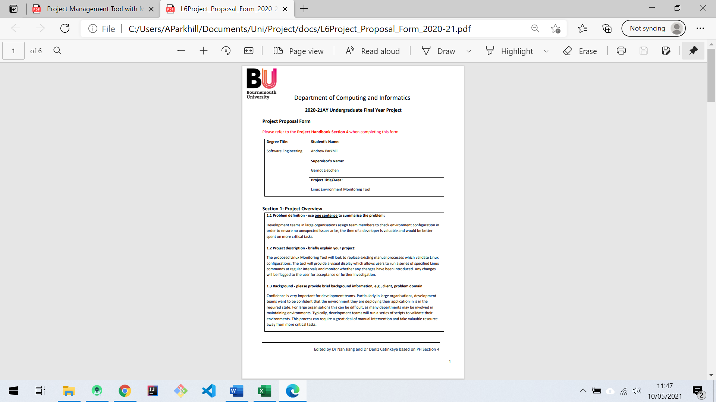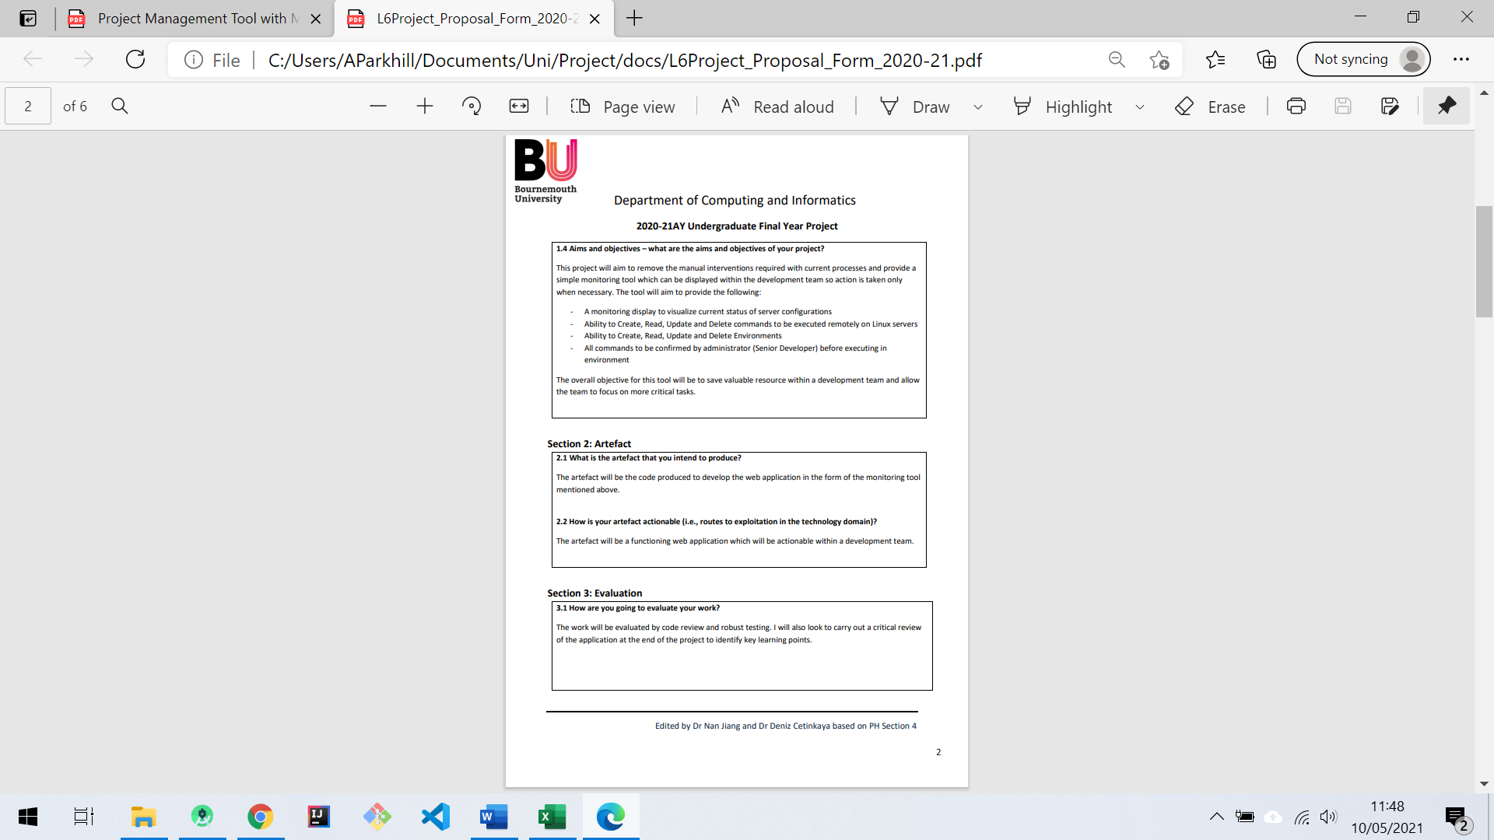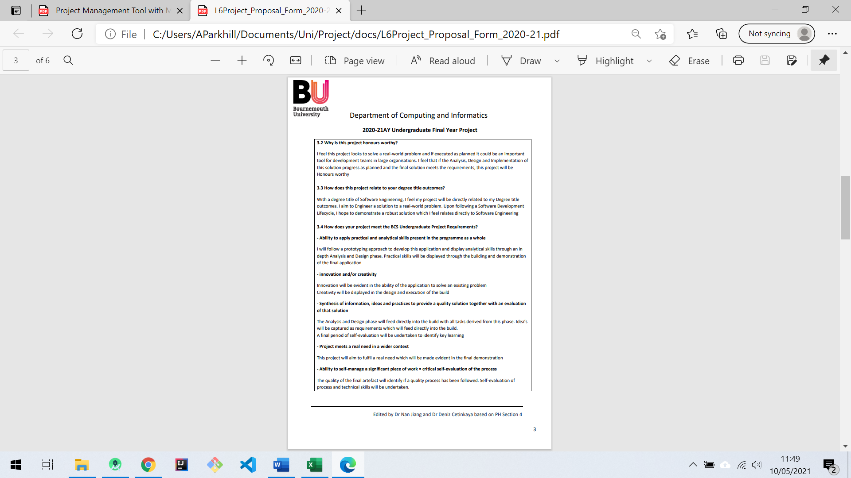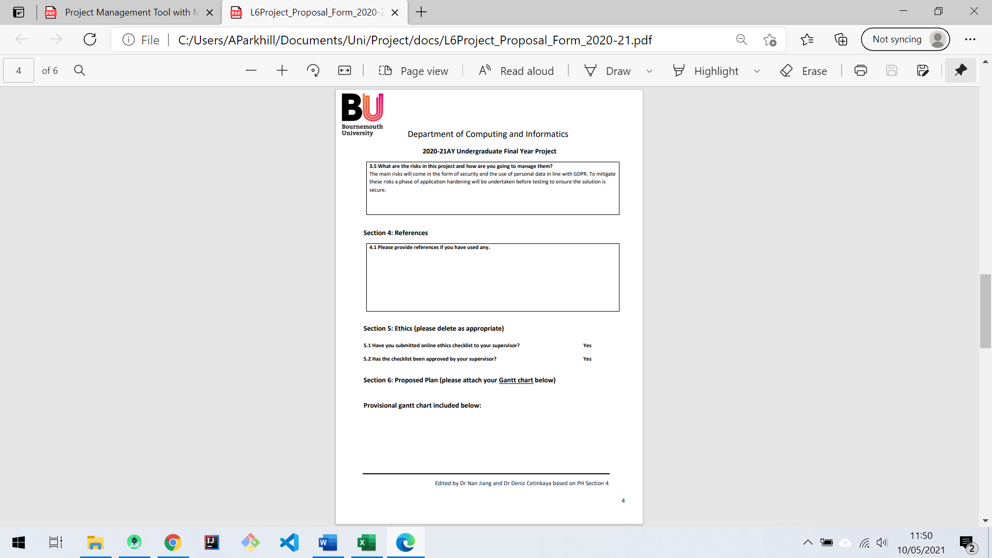

# APPENDIX B: ETHICS CHECKLIST

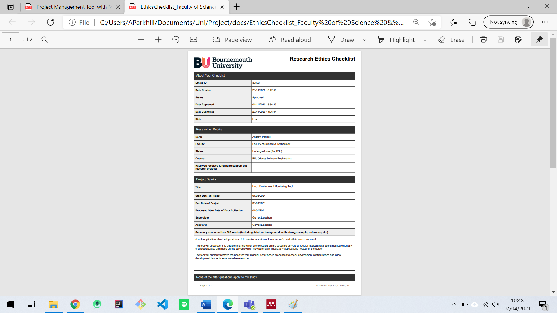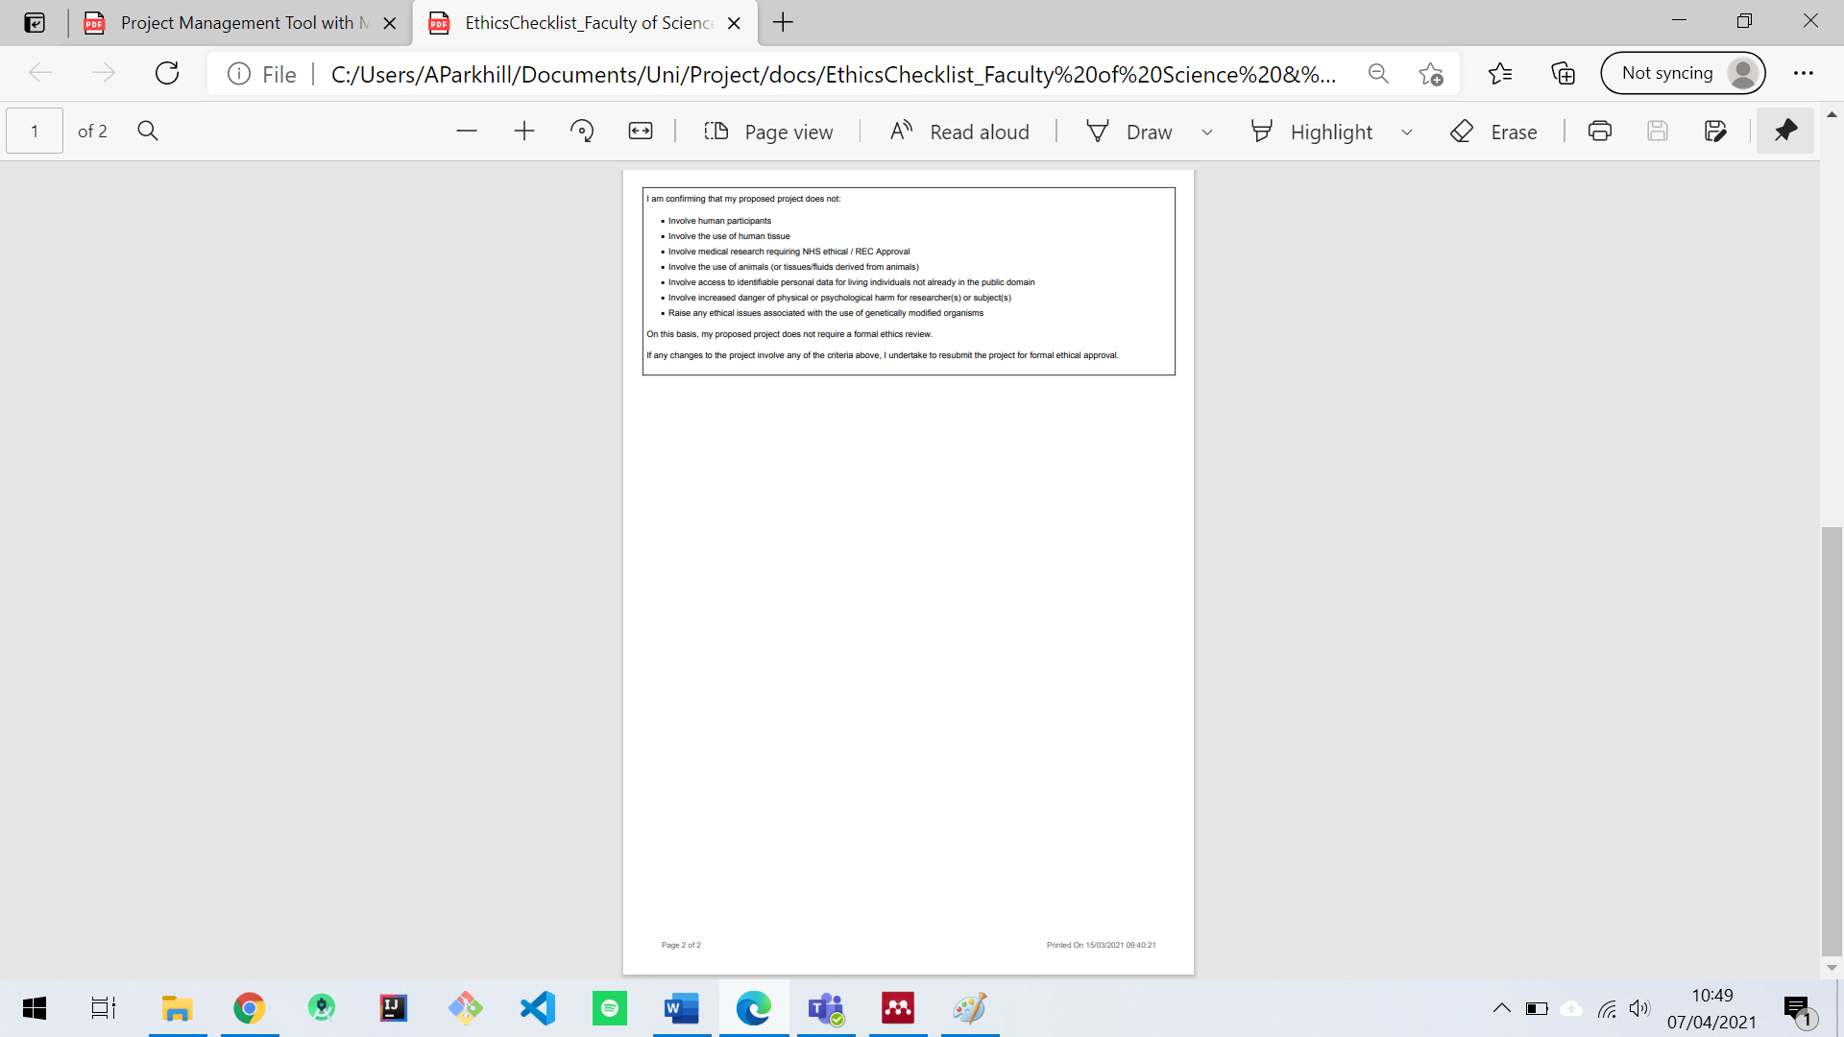

# APPENDIX C: FIRST PROGRESS REVIEW

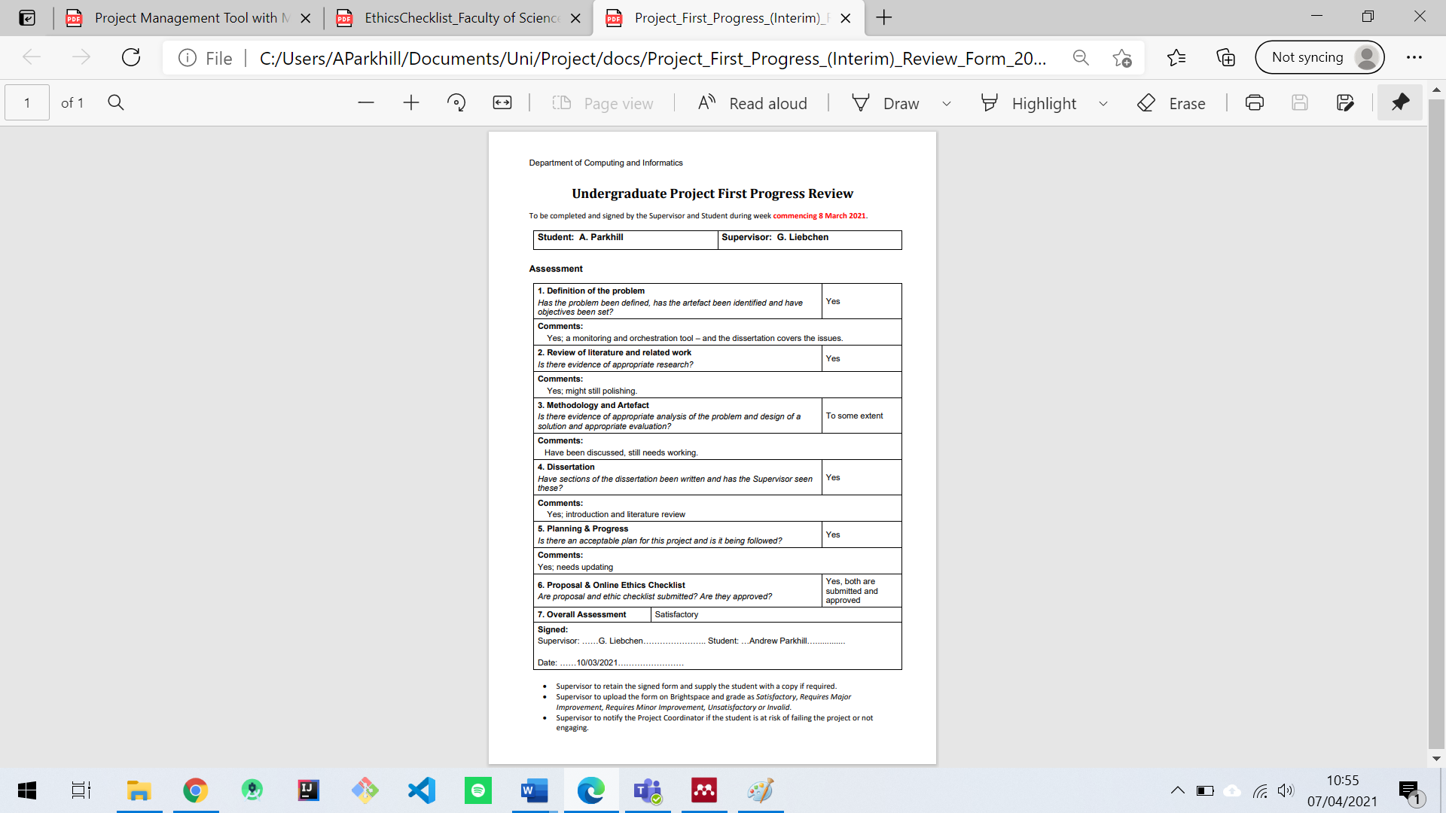

# APPENDIX D: INITIAL GANTT CHART

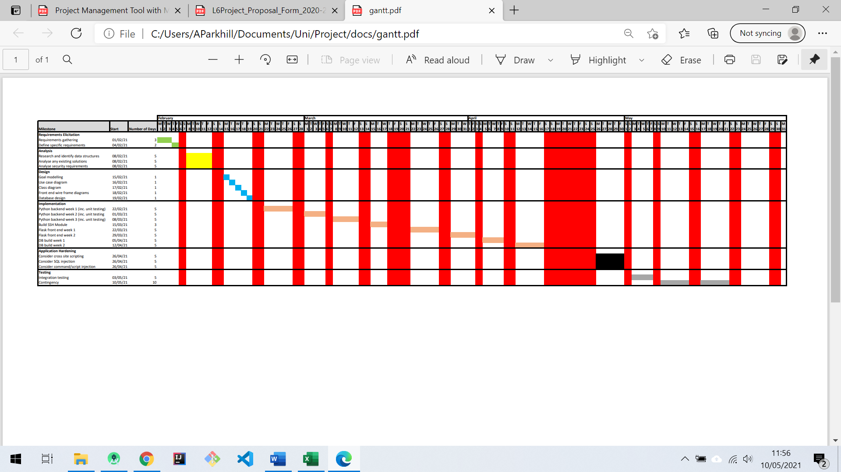

# APPENDIX E: REVISED GANTT CHART

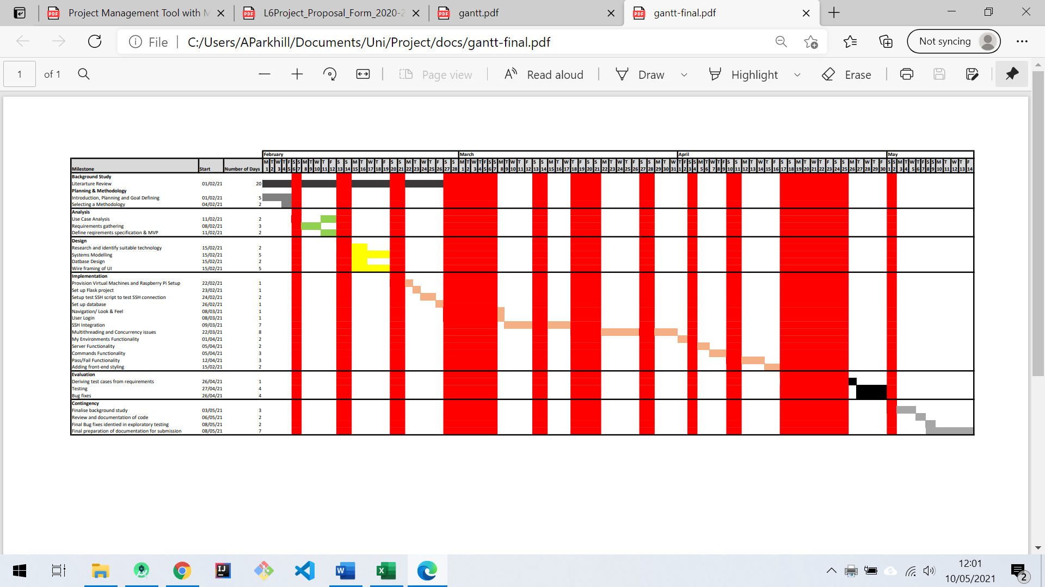

# APPENDIX F: REQUIREMENTS SPECIFICATION

|  |  |
| --- | --- |
| **Software Requirements Specification for Habitat- Linux Monitoring Tool** | |
| **Purpose** | |
| This is a requirements specification for Habitat; A web-based application which acts as a monitoring tool for Linux servers. The application is aimed at organisations of varying size and will allow development teams to monitor a series of Linux environments. Users will have the ability to monitor, browse and edit environments. This document will describe the functional and non-functional requirements of the system and is intended to inform the design of the system. | |
| **Scope** | |
| The scope of this project is a web-based tool which facilitates the monitoring of Linux environments. The application will only operate for Linux based environments. Data will be stored in an SQLite database, which will include secure user details as well as the key data for monitoring environments. Requirements have been defined for a Minimum Viable Product (MVP) which demonstrates the key functionality as well as an extended MVP+ with additional functionality | |
| **Prerequisites** | |
| The tool is aimed at software development teams and a prerequisite is that users and administrators are experienced in navigating Linux environments. SSH keys must also have been set up between the host server and target servers | |
| **Key** | |
| Required in achievement of MVP  Required in achievement of MVP+ (Additional functionality beyond MVP) | |
| **Functional Requirements** | |
| **User** | |
| 1 | User Registration |
| 2 | User Login |
| 3 | Logout |
| 4 (MVP+) | Set timings per environment |
| 5 | Add environment |
| 6 | List environments |
| 7 | Update environment |
| 8 | Delete environment |
| 9 | Add server to environments |
| 10 | List servers in environment |
| 11 | Update server in environment |
| 12 | Delete server from environment |
| 13 | Add command to server |
| 14 | List commands running on server |
| 15 | Update command running on server |
| 16 | Delete command from server |
| 17 | Add expected output to command |
| 18 | Update expected output on command |
| 19 | List expected output of command |
| 20 | Delete expected output from command |
| 21 | Run commands on specified environment |
| 22 | Run commands on all environments |
| 23 | Compare live output with expected output |
| 24 | Highlight failing commands |
| 25 | Highlight failing servers |
| 26 | Highlight failing environments |
| 27 (MVP+) | Accept, Decline or set to investigating any failures |
| 28 (MVP+) | Run comparison on application startup with user specified timings |
| **Admin** | |
| 29 (MVP+) | Login |
| 30 (MVP+) | Approve new environments |
| 31 (MVP+) | Approve new servers |
| 32 (MVP+) | Approve new commands |
| 33 (MVP+) | Approve new expectations |
| **Non-Functional User Interface Requirements** | |
| 34 (MVP) | Login with registration option |
| 35 (MVP) | Home page |
| 36 (MVP) | Environments page outlining current status and linking to servers |
| 37 (MVP) | Environments page facilitates adding, updating, deleting environments |
| 38 (MVP) | Servers page outlining current status of servers within given environment and link to commands |
| 39 (MVP) | Servers page facilitates adding, updating, deleting servers |
| 40 (MVP) | Commands page outlining current status of commands running on server |
| 41 (MVP) | Commands page facilitates adding, updating, deleting commands |
| 42 (MVP) | Button to run commands on a specified environment |
| 43 (MVP) | Button to run commands on all environments |
| 44 (MVP) | Clear highlighting of failures across environment, server and command |
| 45 (MVP+) | Admin dashboard which facilitates approvals |
| 46 (MVP+) | Wallboard mode |

# APPENDIX G: ESTIMATIONS

**Estimation of Development Environment Setup**

|  |  |  |  |  |
| --- | --- | --- | --- | --- |
| **Task** | **Complexity** | **Experience Level** | **Time Estimation** | **Actual Time** |
| Provision Virtual Machine’s | 2 | 0 | 120 | 120 |
| Set up Raspberry Pi | 2 | 0 | 120 | 120 |
| Set up SSH keys for VM’s | 2 | 3 | 60 | 60 |
| Set up SSH keys for Raspberry Pi | 2 | 3 | 60 | 30 |
| Git set up with SSH | 1 | 5 | 30 | 30 |
| Virtual environment setup | 1 | 5 | 30 | 30 |
| Flask project structure setup | 2 | 3 | 120 | 180 |
| DB Setup (SQLite) | 3 | 3 | 180 | 180 |

**Estimation for Delivery of MVP**

|  |  |  |  |  |  |
| --- | --- | --- | --- | --- | --- |
| **Requirement** | **Sub-tasks** | **Complexity**  **(1 - 5)** | **Experience Level**  **(0 – 5)** | **Time Estimation**  **(Minutes)** | **Actual Time** |
| MVP 1  MVP 2  MVP 3  MVP 34 | * Create User Table * Login code extracted from Flask Tutorial * Registration code extracted from Flask Tutorial | 2 | 2 | 180 | 240 |
| MVP+ 4 | * Integrate SSH connection, set timing of command execution per environment | 5 | 1 | 1200 | 2880 |
| MVP 5  MVP 36  MVP 37 | * Create form for adding environments * Create environments template * Create model for environments * Create routing for add environment | 3 | 3 | 120 | 120 |
| MVP 6  MVP 36  MVP 37 | * Create table for viewing environments * Create routing to list environments | 3 | 3 | 120 | 120 |
| MVP 7  MVP 36  MVP 37 | * Create prepopulated form for updating existing environments * Create routing to update environment | 3 | 3 | 120 | 120 |
| MVP 8  MVP 36  MVP 37 | * Create button to delete environment * Add routing to delete environment | 1 | 3 | 60 | 60 |
| MVP 9  MVP 38  MVP 39 | * Create form for adding servers * Create server template * Create model for servers * Create routing for add servers | 3 | 3 | 120 | 120 |
| MVP 10  MVP 38  MVP 39 | * Create table for viewing server * Create routing to list servers | 3 | 3 | 120 | 120 |
| MVP 11  MVP 38  MVP 39 | * Create prepopulated for form updating existing servers * Create routing to update servers | 3 | 3 | 120 | 120 |
| MVP 12  MVP 38  MVP 39 | * Create button to delete server * Add routing to delete server | 1 | 3 | 60 | 60 |
| MVP 13  MVP 40  MVP 41 | * Create form for adding commands * Create command template * Create model for command * Create routing for add command | 3 | 3 | 120 | 120 |
| MVP 14  MVP 40  MVP 41 | * Create table for viewing command * Create routing to list command | 3 | 3 | 120 | 120 |
| MVP 15  MVP 40  MVP 41 | * Create prepopulated form for updating existing commands * Create routing to update servers | 3 | 3 | 120 | 120 |
| MVP 16  MVP 40  MVP 41 | * Create button to delete command * Add routing to delete command | 1 | 3 | 60 | 60 |
| MVP 17 | * Expectation to be added with command | 1 | 4 | 30 | 30 |
| MVP 18 | * Expectation to be listed with command | 1 | 4 | 30 | 30 |
| MVP 19 | * Expectation to be updated with command | 1 | 4 | 30 | 30 |
| MVP 20 | * Expectation to be deleted with command | 1 | 4 | 30 | 30 |
| MVP 21  MVP 42 | * Run commands across environment | 1 | 5 | 720 | 1080 |
| MVP 22  MVP 43 | * Run command across all environments | 2 | 3 | 120 | 120 |
| MVP 23 | * Compare live output with expected output | 3 | 1 | 360 | 360 |
| MVP 24 | * Display failing commands | 3 | 1 | 180 | 360 |
| MVP 25 | * Display failing servers | 3 | 1 | 180 | 360 |
| MVP 26 | * Display failing environments | 3 | 1 | 180 | 180 |
| MVP 35 | * Home Page with description of application | 1 | 1 | 60 | 60 |
| MVP 44 | * Clear highlighting of failures across Environment, Server and Command | 4 | 4 | 360 | 720 |

Estimated time commitment for build: 4,620 (77 hours)

Actual time commitment for build: 7,710 (128.5 hours)

# APPENDIX H: WIREFRAMES

**Home/Index**

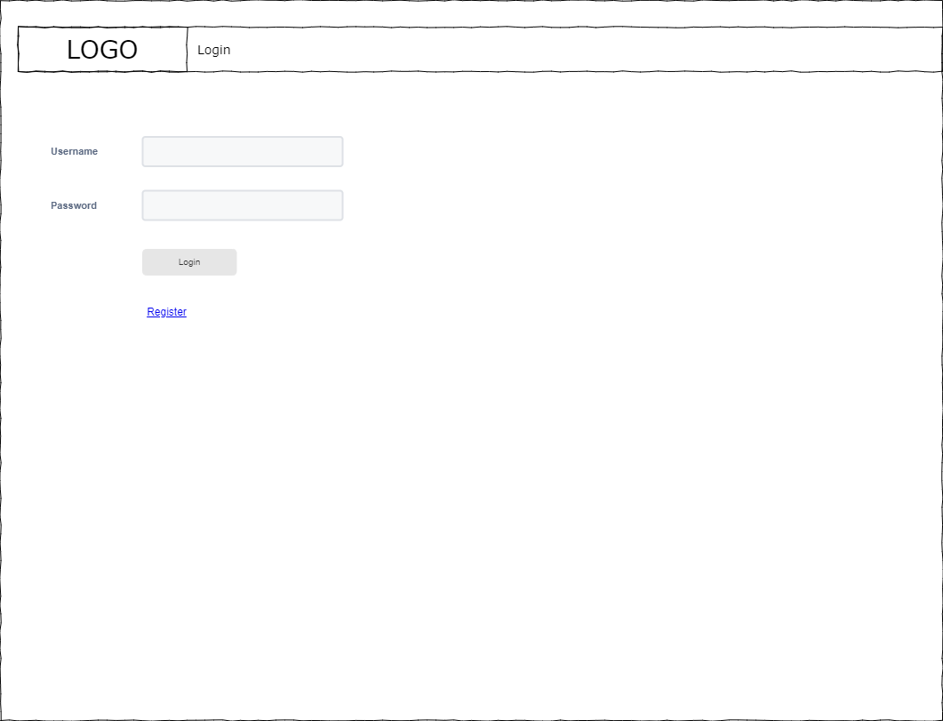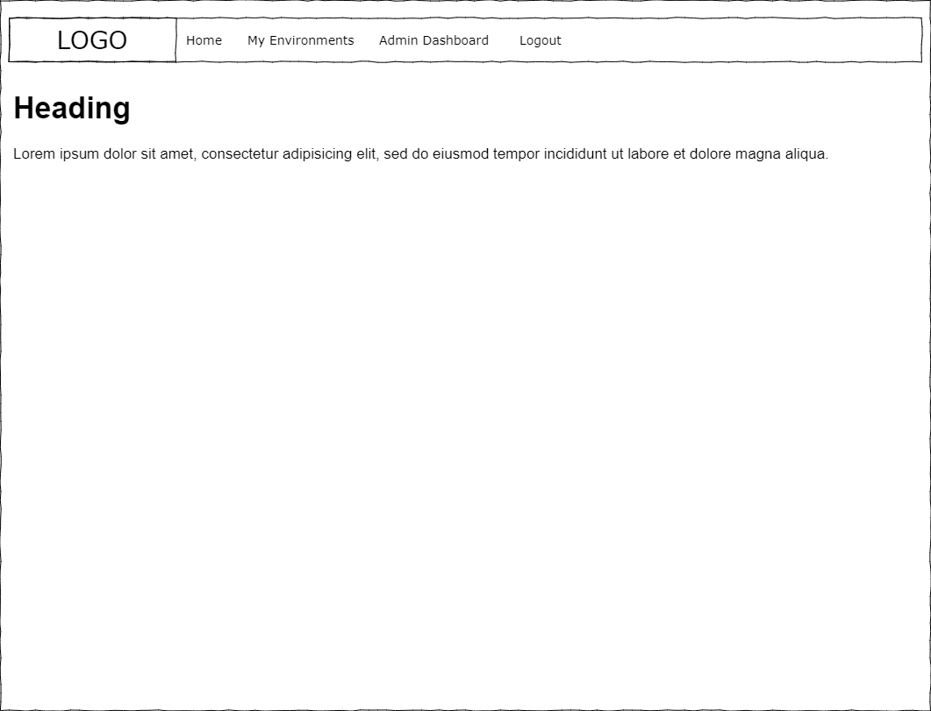

**Login**

**Register**

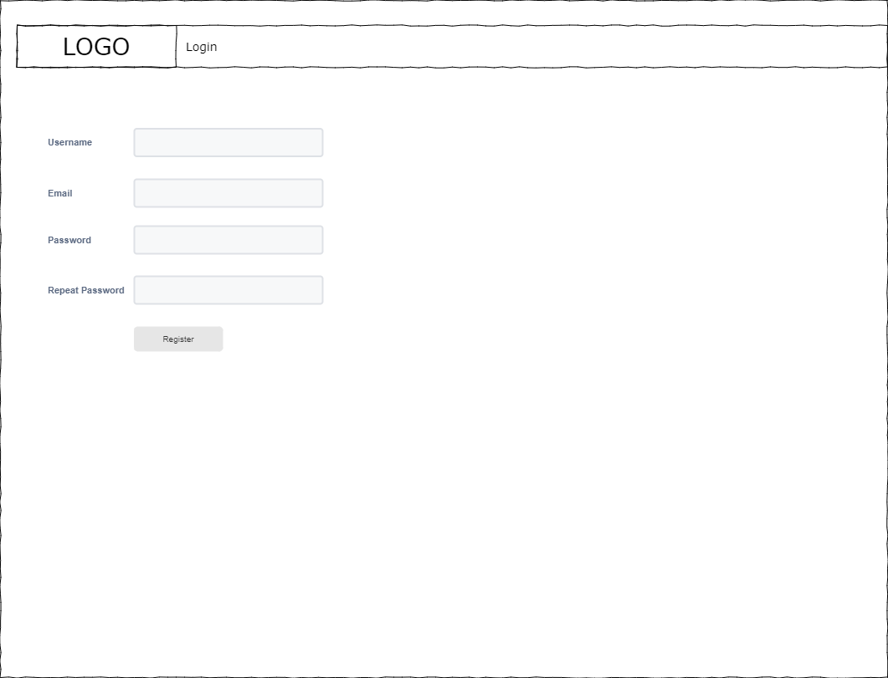

**My Environments**

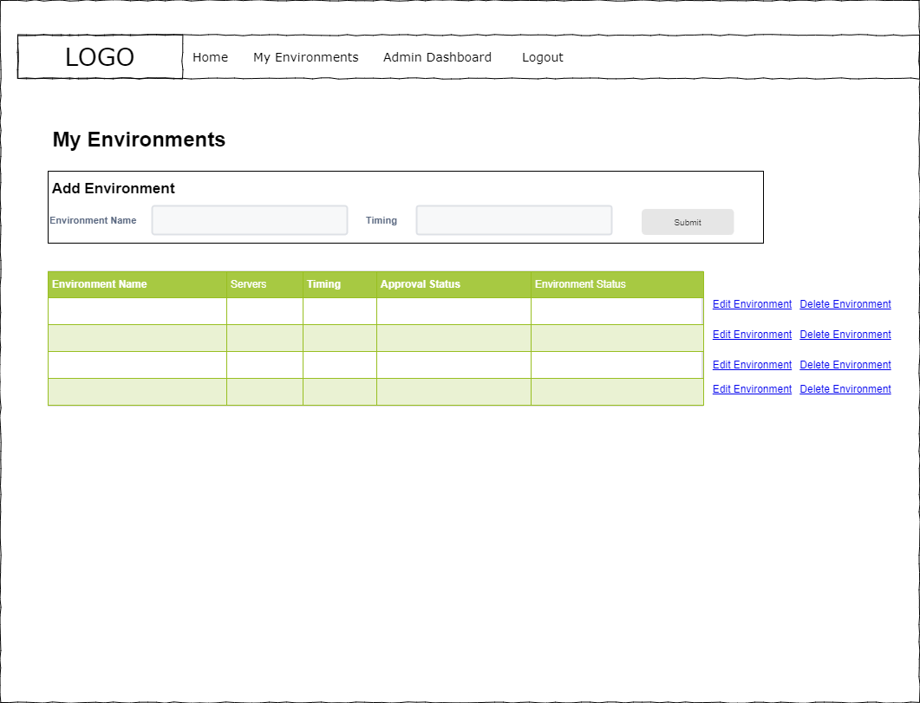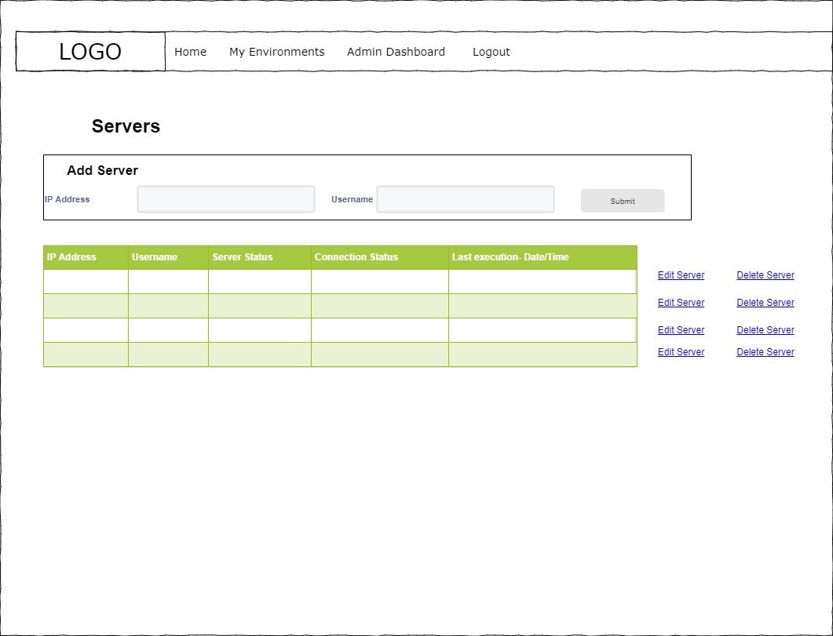

**Commands**

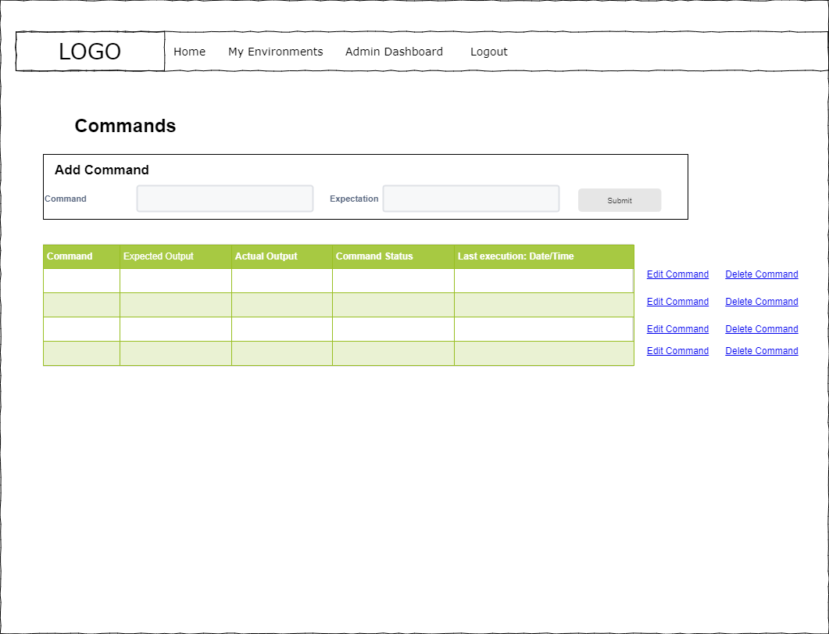

**Servers**



# APPENDIX I: TEST CASES

|  |  |  |  |  |  |  |  |
| --- | --- | --- | --- | --- | --- | --- | --- |
| **ID** | **Derived From** | **Test Description** | **Test Data** | **Expected Outcome** | **Actual outcome** | **Pass/Fail** | **Feedback** |
| 1 | Requirement 1 | User Registration | Username: new_user  Email: [user@user.com](mailto:user@user.com)  Password: password | New user added to database with hashed password | New user added to database with hashed password | **Pass** | Further password validation would be beneficial to improve security |
| 2 | Requirement 1 | Register user with existing username | Username: new_user  Email: user@user.com  Password: password | Error displays on text field prompting for different username | Error displays on text field prompting for different username | **Pass** |  |
| 3 | Requirement 1 | Register user with invalid email | Username: new_user1  Email: user  Password: password | Error displays on text field prompting for different email address | Error displays on text field prompting for different email address | **Pass** |  |
| 4 | Requirement 1 | Register user with duplicated email address | Username: new_user1  Email: user@user.com  Password: password | Error displays on text field prompting for alternate email address | Error displays on text field prompting for alternate email address | **Pass** |  |
| 5 | Requirement 1 | Ensure password hash differs for users with same password | Username: new_user1  Email: user1@user.com  Password: password | Password added to database with different hash from “new_user” | Passworded added to database with different hash from “new_user” | **Pass** |  |
| 6 | Requirement 1 | Ensure that differing passwords are identified in password and repeat password fields | Username: new_user2  Email: [user2@user.com](mailto:user2@user.com)  Password: Kitchen  Repeat Password: Kichen | Error displays confirming that passwords must be equal | Error displays confirming that passwords must be equal | **Pass** |  |
| 7 | Requirement 1 | Error message on missing fields in registration | Submit form with no data | Error requesting that user fills in field | Error requesting that user fills in field | **Pass** |  |
| 8 | Requirement 2 | Error message on missing fields in login | Submit login form with no data | Error prompting for input | Error prompting for input | **Pass** |  |
| 9 | Requirement 2 | Login with incorrect username | Username: kitchen  Password: table | Error message advising of invalid username or password | Error message advising of invalid username or password | **Pass** | Error messaging style could be more consistent. Differing styles currently used |
| 10 | Requirement 2 | Login with valid credentials | Username: new_user  Password: password | User logged in to Home page  Login menu item replace by logout | User logged in to Home page  Login menu item replace by logout | **Pass** |  |
| 11 | Requirement 2 | Login with remember me checkbox ticked | Username: new_user  Password: password | Upon opening new browser window, new_user goes straight to home page | Upon opening new browser window, new_user goes straight to home page | **Pass** |  |
| 12 | Requirement 3 | Logout | Click logout button | User returned to login screen. Logout button changed to login | User returned to login screen. Logout button changed to login | **Pass** |  |
| 13 | Requirement 6 | List my environments | Click my environments link | User navigates to environments page with list of environments | Internal Server Error | **Fail** |  |
| 14 | Requirement 5 | Add valid environment | Name: Environment1  Timing: 30 | Success message displayed and environment added to list with status of “NEW ENVIRONMENT” | Success message displayed and environment added to list with status of “NEW ENVIRONMENT” | **Pass** |  |
| 15 | Requirement 5 | Add invalid environment | Name: Environment1  Timing: text | Error displayed prompting for time interval in seconds between 0 and 120 | Error displayed prompting for time interval in seconds between 0 and 120 | **Pass** |  |
| 16 | Requirement 7 | Update Environment | Click edit environment and update environment1 with:  Name: Environment2  Timing: 35 | Returns user to environments and values updated | Returns user to environments and values updated | **Pass** |  |
| 17 | Requirement 7 | Update environment with invalid timing | Click edit environment and update environment1 with:  Name: Environment2  Timing: text | Display error on timing field | Internal Server Error | **Fail** |  |
| 18 | Requirement 8 | Delete environment | Click delete environment link | Delete environment and display remaining environments or no environments | Delete environment and display remaining environments or no environments | **Pass** |  |
| 19 | Requirement 9 | Add valid server | Navigate to servers through environment: Add server:  IP address: 192.111.111.12  Username:  Server1 | Servers adds to list of servers | Servers adds to list of servers | **Pass** |  |
| 19 | Requirement 9 | Add invalid server | IP address: 192.x.x.x  Username: server2 | Error message displays prompting for valid IP address | Error message displays prompting for valid IP address | **Pass** |  |
| 20 | Requirement 11 | Update Server with valid values | Click edit link on a server and update to:  IP address: 192.111.111.13  Username:  Server1 | Server updates to new values, user redirected to server list | Server updates to new values, user redirected to server list | **Pass** |  |
| 21 | Requirement 11 | Update Server with valid values | Click edit link on a server and update to:  IP address: 192.x.x.x  Username:  Server1 | Error to prompt for valid ip address | Error to prompt for valid ip address | **Fail** |  |
| 22 | Requirement 12 | Delete server | Click delete link beside server | Server deleted and removed from list | Server deleted and removed from list | **Pass** |  |
| 23 | Requirement 13 | Add command | Add command:  Command: lscpu  Expectation: expectated_value | Command added to list of commands | Command added to list of commands | **Pass** |  |
| 24 | Requirement 13 | Add command with no data | Submit empty command fields | Error displayed prompting for data in fields | Error displayed prompting for data in fields | **Pass** |  |
| 25 | Requirement 15 | Update command | Update command with:  Command: python -version  Expected_value: 3.8 | Command updated and list of command displayed | Command updated and list of command displayed | **Pass** |  |
| 26 | Requirement 15 | Update command with no data | Update command with empty data fields | Error prompting user for input | Error prompting user for input | **Pass** |  |
| 27 | Requirement 21 | Run all passing commands | Set up a series of passing commands where expected output matches actual output | All commands pass, server passes | All commands pass, server passes | **Pass** |  |
| 28 | Requirement 21 | Run mixture of passing and failing commands | Set up a series of commands where some expectations match actual outputs and some do not match | Failing commands highlighted in red, server fails, environment fails | Failing commands highlighted in red, server fails, environment fails | **Pass** |  |
| 29 | Requirement 21 | Run mixture of passing, failing and new commands | Add new command with passing expectation, amend existing expectation to fail and run environment | New command passes, existing command fails  Server fails  Environment fails | New command passes, existing command fails  Server fails  Environment fails | **Pass** |  |
| 30 | Requirement 21 | Run with disconnected device | Disconnect a device and run environment | Server shows as disconnected, all command show as failing with no actual output, environment fails | Server shows as disconnected, all command show as failing with no actual output, environment fails | **Pass** |  |
| 31 | Requirement 21 | Run with all devices disconnected | Disconnect all devices | All commands fail, all servers fail, environment fails | All commands fail, all servers fail, environment fails | **Pass** |  |
| 32 | Requirement 22 | Run with all devices connected | Run with all devices connected | Connection status pass  Commands update with pass/fail  Server status & environment status update with pass/fail | Connection status pass  Commands update with pass/fail  Server status & environment status update with pass/fail | **Pass** |  |
| 33 | Requirement  22 | Run with some devices disconnected | Disconnect a device and run environment | All commands fail Server Fails  Environment fails  Connection status set to fail on server and environment | All commands fail Server Fails  Environment fails  Connection status set to fail on server and environment | **Pass** |  |
| 34 | Requirement 22 | Run with mixture of connected/ disconnected devices | Disconnect some of the devices and run all environments | Connection status of server and environments should fail. All commands fail on disconnected devices | Connection status of server and environments should fail. All commands fail on disconnected devices | **Pass** |  |
| 35 | Requirement 23, 24, 25, 26 | Ensure failing commands detected correctly and also highlight server and environment as failing | Run commands and ensure failures are correctly identified at command, server and environment level | Failures in commands trigger failure in server and environment | Failures in commands trigger failure in server and environment | **Pass** |  |
| 36 | Requirement 23, 24, 25, 26 | Ensure passing commands detected correctly and also highlight server and environment as failing | Run commands and ensure passes are correctly identified at command, server and environment level | Passing commands create pass in server & environment | Passing commands create pass in server & environment | **Pass** |  |

# APPENDIX J: DEFECT LOGS

|  |  |  |  |  |  |  |  |  |
| --- | --- | --- | --- | --- | --- | --- | --- | --- |
| **Defect ID** | **Test Case ID** | **Defect Description** | **Test Data** | **Expected Outcome** | **Actual outcome** | **Instruction to recreate** | **Defect Severity** | **Resolved**  **(Y/N) with branch** |
| 1 | 13 | Internal Server Error on viewing environments for new user | Click “my environments” link | User navigates to environments page with list of environments | Internal Server Error | Login is a new user and navigate to “my environments” | High | Y <https://github.com/Kytehill/habitat/tree/defect1_my_environments> |
| 2 | 16 | Internal server error when invalid timing added on edit environment | Click edit environment and update environment with text in timing field | Error requesting integer between 0 and 120 | Internal Server Error | Click edit environment and update environment with text in timing field | High | Y  <https://github.com/Kytehill/habitat/tree/defect2_timing_issue_edit_environment> |
| 3 | 21 | Internal server error when invalid ip address used on editing server | Click edit server and update with invalid ip address:  IP address: 192.x.x.x | Error to prompt for valid ip address | Internal server error | Click edit server and update with invalid ip address:  IP address: 192.x.x.x | High | Y  <https://github.com/Kytehill/habitat/tree/defect3_Validation_issue_edit_server> |

# APPENDIX K: ARTEFACT CONTENTS